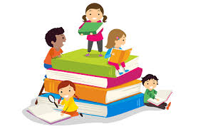Carleton Green’s 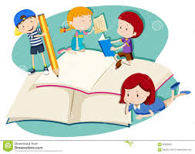
Summer Reading and Writing Challenge
12 week summer reading challenge.
Over the next 12 weeks, we’d like you to complete as many of the challenges as you can; tick them off, make notes, attach photos if you wish. Then bring your completed challenge sheets into school on Friday 4th September. The aim of the challenge is to encourage lots of reading to take place over the summer months to broaden your reading interests, increase your vocabulary, escape into new worlds and switch off. There will also be a prize for the top scores from each year group. (This includes our current Y6 children). Our reading ambassador, Annie Billington, has recommended some books for you to try and set a little quiz for you to have a go at.

A well-chosen text provides rich language models and structures from which children can learn how writing works and the effect it can have on a reader. If you want confident young writers, read aloud and share high quality texts across a range of genres, reflecting a range of writing styles. Choose texts that are rich in vocabulary, and enable children to comprehend beyond their own reading fluency level. A rich reading environment demonstrates the written word in all its forms and shares how writing can be used for thinking, for communication and as a means of expression. With exposure to a variety of texts, enriching experiences children will be able to find their own reasons to write and develop a style that fits the purpose, audience and form intended. Children draw on their experience of reading when shaping their own writing. When children have explored a range of texts across genres, they form an understanding and appreciation of how language functions and how best to use this when writing themselves.

Story writing challenge
Reading and writing are like fish and chips, salt and vinegar, they complement each other. Therefore, alongside the Reading Challenge we are also setting a Story Writing Challenge. Your story can be based upon one of the books you’ve read, can be a new adventure for one of the characters, can be a sequel or can be a completely original idea all of your own. You can choose to present your story however you choose: it can be typed, handwritten, illustrated, presented as a book, it is totally up to you.
Now for the rules…. Each Year group has a word allowance and we challenge you to stick to it! You do not have to meet the word allowance but you cannot exceed it.
Using your current year group (not the one you will be in, in September) check your word allowance
EYFS 30 words, Y1 100 words, Y2 200 words, Y3 300 words, Y4 400 words, Y5 500 words, Y6 600 words.
An adult may scribe and present the story for our younger children but the ideas must be the children’s own.

Our advice is, read, read, read and read some more. Get lots of ideas before you begin your story then draft, edit, improve, edit, improve and when you are happy with your final version present it in a way that suits you and the style of your story.
To be entered into the Year group prize competition your story must be handed in by Friday 4th September.

If you have any questions please contact us on head@carletongreen.lancs.sch.uk n.jones@carletongreen.lancs.sch.uk

Happy reading and story writing
Mrs McGrath and Mrs Jones
12 Week Summer Reading Challenge EYFS/ KS1
For our younger children (who cannot read fluently yet) the challenges that involve them reading alone can be to look at pictures and tell the story how they choose.
See how many of the 12 reading challenges you can complete.
Ask an adult to make notes about the title, author and your enjoyment of the text.
Read a book about an animal. | Read a book an adult in your family enjoyed as a child. (see new books old favourites sheet) | Read a book with a boy’s name in the title
Read a book with a girl’s name in the title | Read a book from this list  https://www.commonsensemedia.org/lists/50-books-all-kids-should-read-before-theyre-12 | Read a book about a magical character or place.
Read a non fiction book. | Read a book about a child the same age as you. | Read a book that’s won an award.
Read a book that makes you laugh. | Read a book set in a different country | Read a magazine or comic.
Who , Where, When EYFS / KS1
See how many of the 12 reading challenges you can complete.
Make notes about who, when, where and your enjoyment of the text.
Read to a younger person | Listen to an audio book/ CD of a favourite story. | Read to yourself in bed.
Read outside (garden, park, beach). | Ask an adult you don’t live with to read you a story using technology (skype, phone, zoom ect)Ask your parents to set this up for you. | Read while on a journey.
Share a book with a pet or a toy. | Watch a story being read on cbeebies. | Read a story you know well to an adult (use the pictures)
Read first thing in the morning, as soon as you wake up. | Share a story with an adult (takes turns to read, who has the best story telling voice?) | Read to your favourite teddy

New Books and Old Favourites EYFS / KS1
Join the free online website https://www.lovereading4kids.co.uk
Read extracts from 4 new books, choose 1 to carry on reading, note down the titles and autho.

Ask 4 people in your family for the name of their favourite book as a small child, choose 1 to read.

Name 4 books you love, choose 1 to re-read
Recommended reading and book quiz
from Carleton Green’s reading ambassador
Annie Billington

- J.K Rowling – Harry Potter books
- Onjali Q. Raúf – The Boy at the Back of the Class
- R.J Palacio - Wonder
- C.S Lewis – Narnia
- Holly Smale – Geek Girl
- Enid Blyton – Secret Seven, Famous Five
- Cath Howe – Ella on the Outside
- Jeff Kinney – Diary of a Wimpy Kid
- Neil Gaiman – Coraline
- Edith Nesbit – The Railway Children
- Roald Dahl
- David Walliams
- E.B White – Charlotte’s Web
- P.L Travers – Mary Poppins
- Lou Kuenzler – Princess Disgrace
- L. Frank Baum – The Wonderful Wizard of Oz
- Astrid Lindgren – Pippi Longstocking
- Dr Seuss
- Beatrix Potter - Peter Rabbit
- Julia Donaldson

Reminder: These recommended books have been sorted by age. Younger children’s books are near the bottom and older children’s books are at the top

Ks1 Quiz
- Who found the turnip in The Enormous Turnip?
- Who ate the Gingerbread man in the story, ‘The Gingerbread Man’?
- What Julia Donaldson book includes the characters Mouse, Fox, Owl and Snake?
- Who wrote Fantastic Mr Fox?
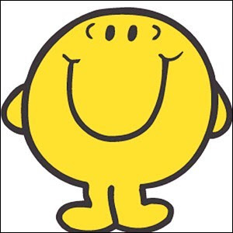
- Which of the Mr. Men is this?
- Who wrote the Snail and the Whale?
- Name the characters in the Little Red Hen.
- What does the Ugly Duckling turn into at the end of the story?
- Which animal is first on the broom with the witch in “Room on the broom”?
- What is the name of the little boy who wont share in “Our house”?
- Why is Elmer different to the other elephants?
- What does Cinderella lose as she runs away from the ball at Midnight?

