Robins Homework
2nd October 2020
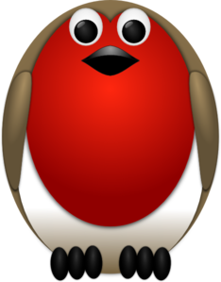
Tasks
Writing – see Education City https://go.educationcity.com/
Maths – see Education City https://go.educationcity.com/
Reading – Create a new front cover for the book you are reading. Can you give clues in the picture as to what the book might be about?
Times tables: Y2’s - Times tables rockstars https://ttrockstars.com/beta/
Y1’s – Continue to practice in 2’s and 5’s with an adult at home
IDL: Three sessions of IDL to be completed at home. Remember your username is your surname followed by the initial of your first name @ the school postcode eg boyds@fy67tf and your password is pass.
Spellings –
Group 1: bug, web, log, red
Group 2: light, sight, height, might, right, thigh
Group 3: fright, live, bike, knight, tries, replied

