Robins Homework
9th October 2020
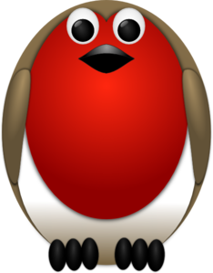
Tasks
Writing – see Education City https://go.educationcity.com/
Maths – see Education City https://go.educationcity.com/
Reading – draw a picture and write a sentence telling me your favourite part of our class story The Twits.
Topic - choose some photographs of when you were a baby, toddler, pre-school, Ducklings and now. Put them in order starting from the earliest to more recent. Explain how you have changed over time. Please email these pictures and explanations to me.
Times tables: Y2’s - Times tables rockstars https://ttrockstars.com/beta/
Y1’s – Continue to practice in 2’s and 5’s with an adult at home
IDL - three sessions of IDL to be completed at home. Remember your username is your surname followed by the initial of your first name @ the school postcode eg boyds@fy67tf and your password is pass.
Spellings –
Group 1: map, tap, cap, bap
Group 2: tail, snail, rail, nail, pain, rain
Group 3: sprain, quaint, straight, praise, strain, bait

