Robins Homework
10th September 2021
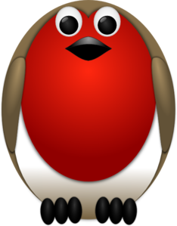
Tasks
Writing – see Education City https://go.educationcity.com/
Maths – see Education City https://go.educationcity.com/
Reading – read for at least 10 minutes every night. You could share this with an adult and read a couple of pages in turn. Then discuss what you’ve read or what might happen in the rest of the story.
Times tables -
Y2’s - Times tables rockstars https://ttrockstars.com/beta/
Y1’s – consolidate your numbers bonds to 10 and 20 (see number bond sheet)
IDL - three sessions of IDL to be completed at home. Remember your username is your surname followed by the initial of your first name @ the school postcode eg boyds@fy67tf and your password is pass. Year 1’s your accounts are still being set up so please bear with us.
Spellings
Group 1: cat, dog, chip, snip, frog, rain, moon, see
Group 2: made, spade, always, holiday, rain, Spain, shame, wave
Group 3: holiday, display, fame, shame, boats, chairs, shapes, homes, learn, circle

