Robins Homework
1st October 2021
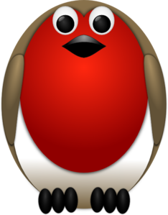
Tasks
Maths – Education City
English – Education City
Reading – Create a new front cover for the book you are reading. Can you give clues in the picture as to what the book might be about?
Times tables -
Y2’s - Times tables rockstars https://ttrockstars.com/beta/
Y1’s – Continue to practice counting in 5’s and 10’s at home.
IDL - three sessions of IDL to be completed at home. Remember your username is your surname followed by the initial of your first name @ the school postcode eg boyds@fy67tf and your password is pass. Year 1 accounts are now active, if you have any trouble logging on please email me.
Spellings
Group 1: sip, hip, tip, flip, lip, ship
Group 2: bee, tree, pea, tea, key, donkey
Group 3: screen, queen, journey, chimney, season, please, complete, theme

