Robins Homework
8th October 2021
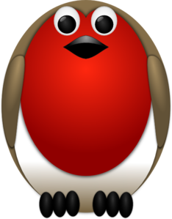
Tasks
Maths – Education City
English – Education City
Science - Education City
Reading – Read at home and log in your reading record.
Times tables -
Y2’s - Times tables rockstars https://ttrockstars.com/beta/
Y1’s – Continue to practice counting in 2’s, 5’s and 10’s at home.
IDL - three sessions of IDL to be completed at home. Remember your username is your surname followed by the initial of your first name @ the school postcode eg boyds@fy67tf and your password is pass. Year 1 accounts are now active, if you have any trouble logging on please email me.
Spellings
Group 1: cat, kiss, cup, kick, cap, car
Group 2: school, kick, key, cowboy, carrot, cart
Group 3: cupboard, computer, kite, cottage, school, echo, caravan, quick

