Robins Homework
15th October 2021
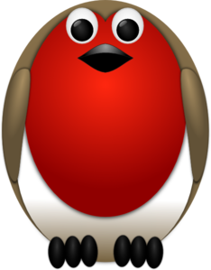
Tasks
Maths – Number bonds – see separate sheet. Use the 100 square below if needed.
English – Write about a day in the life of Samuel Pepys. Think about all our learning so far on the Great Fire of London
Reading – Read at home and log in your reading record.
Times tables -
Y2’s - Times tables rockstars https://ttrockstars.com/beta/
Y1’s – Login to Numbots (login details in reading records)
IDL - three sessions of IDL to be completed at home. Remember your username is your surname followed by the initial of your first name @ the school postcode eg boyds@fy67tf and your password is pass. Year 1 accounts are now active, if you have any trouble logging on please email me.
Spellings
Group 1: see, sun, mess, pass, stop, less
Group 2: small, dress, house, cheese, smell, unless
Group 3: city, dance, mice, circle, mouse, horse, stress, unless

