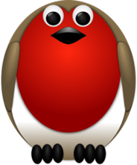
October Half Term Homework

Autumn Poem  Write an Autumn poem that you can share with the class after half term. | Autumn Leaf Character  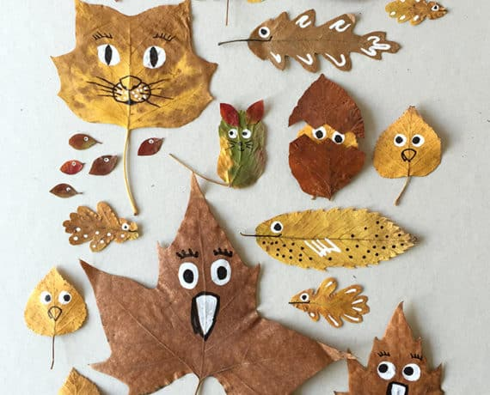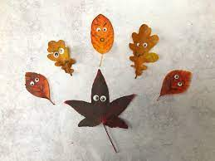  Create a character using leaves. Can you write a story that includes this character?
Cooking  Find an autumn recipe. Write a list of the ingredients, go shopping and then get cooking! | Number bonds  Make a poster to show either the number bonds to 10, 20 or 100
Pumpkin Carving  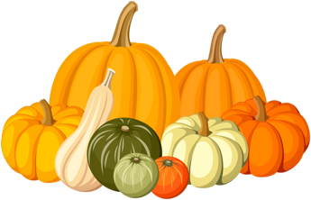  Design a pumpkin carving and then carve it ready for Halloween. Perhaps you could use the inside of the pumpkin in your cooking! | Reading  Read at home and log in your reading record. Perhaps you could find different places to read during the Autumn break.

Times tables -
Y2’s - Times tables rockstars
Y1’s – Login to Numbots

IDL - three sessions of IDL to be completed at home. Remember your username is your surname followed by the initial of your first name @ the school postcode eg boyds@fy67tf and your password is pass. Year 1 accounts are now active, if you have any trouble logging on please email me.

Group 1: fox, fix, fast, huff, fish, fan
Group 2: leaf, finish, staff, fluff, fire, find
Group 3: forest, scarf, dolphin, photograph, earmuffs, different, laugh, enough

