Robins Homework
19th November 2021
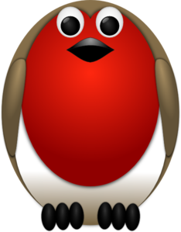
Tasks
Maths – This week we have been looking at money. Please complete one or some of these activities: count up the money in your money jar, count any loose change in your house and add up the amounts, go to the shop and add up prices of some of the items.
English – Last week we learnt about rhyming poems. Write a poem about an activity or place you are interested in or have done over the weekend. Eg swimming, Blackpool Tower
Reading – Read at home and log in your reading record.
Times tables -
Y2’s - Times tables rockstars https://ttrockstars.com/beta/
Y1’s – Login to Numbots (login details in reading records)
IDL - three sessions of IDL to be completed at home. Remember your username is your surname followed by the initial of your first name @ the school postcode eg boyds@fy67tf and your password is pass. Year 1 accounts are now active, if you have any trouble logging on please email me.
Spellings
Group 1: even, tube, cube, bone, nose, rope
Group 2: cube, tube, flame, lake, even, these
Group 3: globe, home, athlete, compete, flute, cube, slide, time

