Robins Homework
26th November 2021
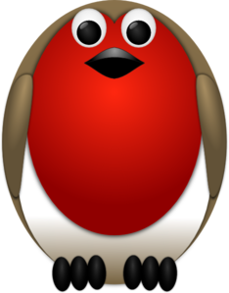
Tasks
Maths – Use items around your house e.g. pasta, playdough to make repeated addition patterns. Can you then write them as a multiplication (see image below to help)
English – Now that we have learnt about shape poems can you write one based on an object or activity of your choice eg lollipop, Big Ben, icicle etc. You can make it rhyme if you wish but remember it doesn’t have to.
Reading – Read at home and log in your reading record.
Times tables -
Y2’s - Times tables rockstars https://ttrockstars.com/beta/
Y1’s – Login to Numbots (login details in reading records)
IDL - three sessions of IDL to be completed at home. Remember your username is your surname followed by the initial of your first name @ the school postcode eg boyds@fy67tf and your password is pass. Year 1 accounts are now active, if you have any trouble logging on please email me.
Spellings
Group 1: this, then, that, them, three, bath
Group 2: think, those, thick, thorn, with, mouth
Group 3: there, their, third, earth, mouth, theme, those, thought

