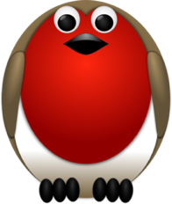
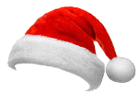
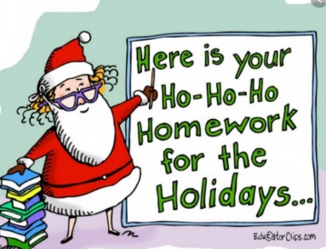

Christmas Homework

Maths
-Practise your times tables.
-Help out in the kitchen and weigh some ingredients for some Christmas cooking/ baking.
-Count how many Christmas trees you see while out for a walk.
-Have you noticed any repeating patterns in the Christmas lights? Shapes, colours etc

English
You have been given 2 school reading books to read over the holidays and we would like you to read at least 4 home books from the following options;

-Read a Christmas story in bed
-Read a Christmas story with a sibling, a pet, a cousin or a teddy.
-Read a Christmas story with a relative via zoom or in person.
-Watch CBeebies bedtime stories or watch a story on Jackanory.
-Listen to an audio story.
-Read a Christmas story while in the car travelling to the shops.
-Start a chapter book with a grown up.
-Read a story that is totally unrelated to Christmas.
-Read a comic or a magazine.

Choose 2 books to answer these questions about (this is a verbal activity and does not need writing down)
-Who is the main character?
-Would you describe them as a good character a bad character? Why?
-Would you like to read another book about this character?
-Did you enjoy the ending? What could have happened to make the ending even better?
-Can you think of an alternative title for the story?

PSHE
Over the holidays as a family try some of these:

-Say thank-you to someone who has made you happy.
-Say thank-you to someone who has done something for you.
-Smile and say good morning to your parents and siblings.
-Tell someone why you love them.
-Tell someone why they are special to you.
-Think about why you are special and unique.
-Make something for someone else (a picture, a card, a cake, a meal)
-Learn to tie your shoelaces.
-Enjoy some family time.

