Robins Homework
7th January 2022

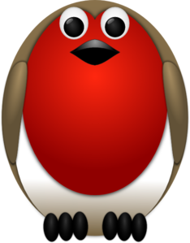

Tasks
Maths – Education City
English – Education City
Reading – Read your school reading book at home and ask a grown up to write in your reading record. Try and read a little bit every night.
Times tables -
Y2’s - Times tables rockstars https://ttrockstars.com/beta/
Y1’s – Login to Numbots
IDL - three sessions of IDL to be completed at home. Remember your username is your surname followed by the initial of your first name @ the school postcode eg boyds@fy67tf and your password is pass.
Spellings
Group 1: hand, sand, lamp, nest, cash.
Group 2: bread, treat, seat, beat, tread, head, wealthy, repeat.
Group 3: found, pound, mountain, cloud, bounce, fountain, lounge, drought.

