Robins Homework
14th January 2022

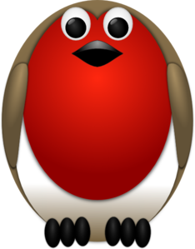

Tasks
Maths – Do a survey of your family at home and find out what their favourite woodland animal is. Can you create a tally chart and then a pictogram to display your data? Think about all our learning over the past two weeks on tally charts and pictograms!
English – Write a recount of our outdoor day on Tuesday. Tell me what you learnt and what your best part of the day was.
Topic - What are the main things that have happened in your life? Create a timeline of events and dates for your live including birth, starting Carleton Green, going into Year 1, going into Year 2 etc.
Reading – Read your school reading book at home and ask a grown up to write in your reading record. Try and read a little bit every night.
Times tables -
Y2’s - Times tables rockstars https://ttrockstars.com/beta/
Y1’s – Login to Numbots
IDL - three sessions of IDL to be completed at home. Remember your username is your surname followed by the initial of your first name @ the school postcode eg boyds@fy67tf and your password is pass.
Spellings
Group 1: clan, clam, clap, clog, club
Group 2: air, chair, fair, hair, lair, pair, stair, cairn
Group 3: rehearse, research, search, unheard, yearn, earthquake, earthworm, heard

