**Robins Homework**

**21st January 2022**

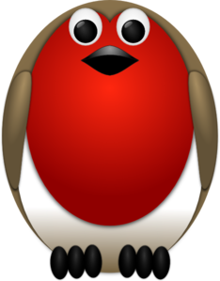

**Tasks**

**Maths** – Create a picture using 2D or 3D shapes and then label the shapes you’ve used. Can you describe some of their properties too? Eg a square has 4 equal sides.

**English** – Look at the picture below of a Lake District landscape. Can you write a description of what you can see in the picture? Think about your senses and see if you can include an expanded noun phrase.

**Reading –** Read your school reading book at home and ask a grown up to write in your reading record. Try and read a little bit every night.

If you haven’t already done so, please can you email me a photo of you reading in your favourite place.

**Times tables -**Y2’s - Times tables rockstars <https://ttrockstars.com/beta/>   
Y1’s – Login to Numbots

**IDL -** three sessions of IDL to be completed at home. Remember your username is your surname followed by the initial of your first name @ the school postcode *eg boyds@fy67tf* and your password is *pass.*

**Spellings**Group 1: ring, rang, song, king, longer, sing

Group 2: can’t, wasn’t, hadn’t, I’m, we’re, they’re

Group 3: wouldn’t, couldn’t, wasn’t, hadn’t, could’ve, would’ve, doesn’t, shouldn’t

