Robins Homework
28th January 2022

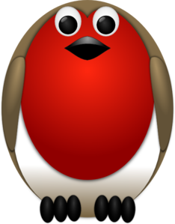

Tasks
Maths – 3D shapes – use match sticks/straws/spaghetti and blu-tac to make 3 shapes. Can you then tell me about their properties eg faces, vertices and edges? (see picture below)
English – Research about Beatrix Potter and write 8 facts.
Reading – Read your school reading book at home and ask a grown up to write in your reading record. Try and read a little bit every night.
If you haven’t already done so, please can you email me a photo of you reading in your favourite place.
Times tables -
Y2’s - Times tables rockstars https://ttrockstars.com/beta/
Y1’s – Login to Numbots
IDL - three sessions of IDL to be completed at home. Remember your username is your surname followed by the initial of your first name @ the school postcode eg boyds@fy67tf and your password is pass.
Spellings
Group 1: crab, grab, step, swim, frog, spot.
Group 2: liked, looked, helped, talked, walking, kicking
Group 3: guessed, fixed, followed, helped, swimming, shopping, jumping, hitting.

