Robins Homework
25th February 2022

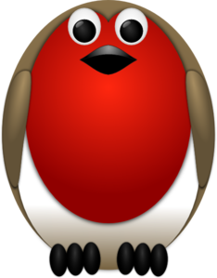

Tasks
Maths – Create a poster about the 2 and 5 times tables.
English – Find out about William Wordsworth and write 8 facts.
Reading – Read your school reading book at home and ask a grown up to write in your reading record. Try and read a little bit every night.
Times tables -
Y2’s - Times tables rockstars https://ttrockstars.com/beta/
Y1’s – Login to Numbots
IDL - three sessions of IDL to be completed at home. Remember your username is your surname followed by the initial of your first name @ the school postcode eg boyds@fy67tf and your password is pass.
Spellings
Group 1: band, best, belt, felt, camp, sink
Group 2: drove, wrote, went, rode, drank, spoke, forgot
Group 3: forgetful, beautiful, powerful, painful, hopeful, useful

