Robins Homework
11th March 2022

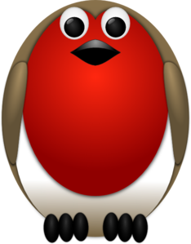

Tasks
Maths – We have been learning about different types of measurement over the week eg length, mass, capacity and volume. Can you help a grown up cook a meal or bake a cake that would involve using some of these measurements. Send me in a photo of what you’ve done.
English – Thinking about our poetry over the past couple of weeks write a poem about the Lake District. Think about rhyme and using description in your poem too.
Reading – Read your school reading book at home and ask a grown up to write in your reading record. Try and read a little bit every night.
Times tables -
Y2’s - Times tables rockstars https://ttrockstars.com/beta/
Y1’s – Login to Numbots
IDL - three sessions of IDL to be completed at home. Remember your username is your surname followed by the initial of your first name @ the school postcode eg boyds@fy67tf and your password is pass.
Spellings
Group 1: by, go, be, do, our, so
Group 2: wild, told, most, class, sure, floor
Group 3: improve, everybody, people, would, should, parents

