Robins Homework
6th May 2022
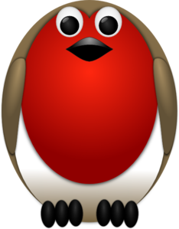

Tasks
Maths – Education City
English – Over the past couple of weeks we have been writing poetry based on animals. Can you produce an animal poem that is in the shape of your chosen animal?
Reading – Read your school reading book at home and ask a grown up to write in your reading record. Try and read a little bit every night.
Topic – Create a garden in a shoebox. This is to be of your own garden. Can you label the different plants and flowers that you have in your garden? This homework is linked to our topic and doesn’t need to be in school until the w/c 23rd May. (See image below – but don’t get too carried away!!)
Times tables -
Y2’s - Times tables rockstars https://ttrockstars.com/beta/
Y1’s – Login to Numbots
IDL - three sessions of IDL to be completed at home. Remember your username is your surname followed by the initial of your first name @ the school postcode eg boyds@fy67tf
**NOTE – IDL Passwords have been updated by the IDL company and you should find them in your child’s reading record.**
Spellings –
Group 1: girl, skirt, bird, fern, herb, germ, turn, burn
Group 2: table, apple, wobble, bobble, shuffle, dazzle, beetle, kettle,
Group 3: middle, bottle, marble, trifle, tickle, castle, sprinkle, purple, prove, improve

