Robins Homework
17th June 2022
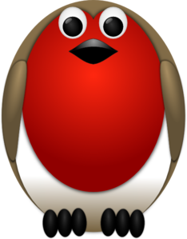

Tasks
Maths – Education City
Writing – Research an unusual animal (like the ones we’ve read about in class). Produce a fact file for your animal. This can be a poster or a piece of writing.
Reading – Read your school reading book at home and ask a grown up to write in your reading record. Try and read a little bit every night.
Times tables -
Y2’s - Times tables rockstars https://ttrockstars.com/beta/
Y1’s – Login to Numbots
IDL - three sessions of IDL to be completed at home. Remember your username is your surname followed by the initial of your first name @ the school postcode eg boyds@fy67tf
**NOTE – IDL Passwords have been updated by the IDL company and you should find them in your child’s reading record.**
Spellings –
Group 1: her, fair, pair, hair, chair, care, share, wear, where, love
Group 2: worm, word, world, worse, worst, work, worth, worship, should, would
Group 3: worship, wording, worse, working, worked, worst, worth, should, would

