Doves Homework
30th September 2022
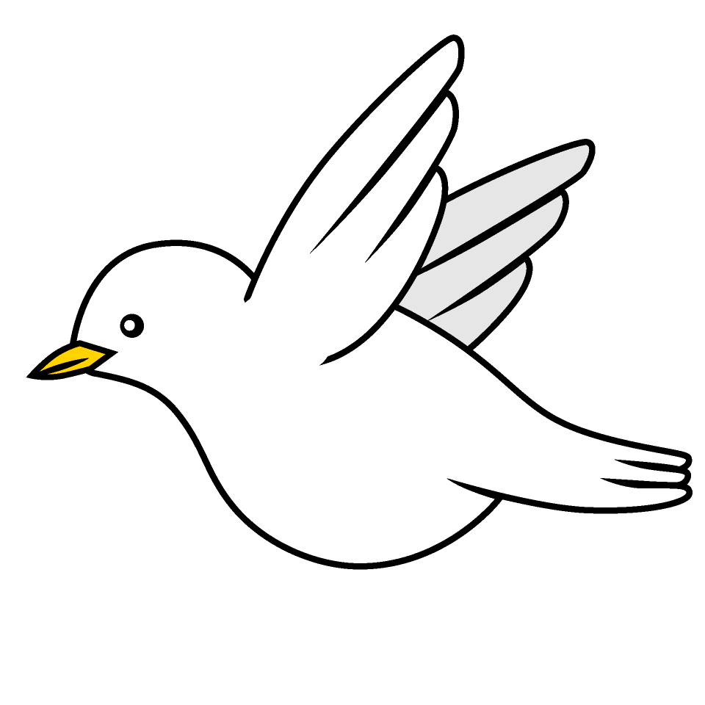
Tasks
Maths – Education City
Writing – We’ve spent 4 weeks reading Stone Age Boy and have completed lots of work based on the story. Produce a character profile of either the Stone Age Boy or Om – can you include descriptions of their appearance, their character, their thoughts and feelings? Remember to give reasons with your thoughts.
Reading – Read your school reading book at home and ask a grown up to write in your reading record. Try and read a little bit every night.
More books can be accessed through the website Oxford Owl.
Times tables -
Times tables rockstars https://ttrockstars.com/beta/
IDL - three sessions of IDL to be completed at home. Remember your username is your surname followed by the initial of your first name @ the school postcode eg boyds@fy67tf
Spellings –
Group 1 – wad, wallet, wand, want, wash, watch
Group 2 – knight, knee, knit, knife, knuckle, knock
Group 3 – giant, ginger, giraffe, general, genius, gentle
Group 4 – geometry, damage, emergency, energy, engineer, digest

Also, using the common exception words list in the General Resources section of the home learning page begin learning the spellings highlighted in yellow for your year group.

