Doves Homework
14th October 2022
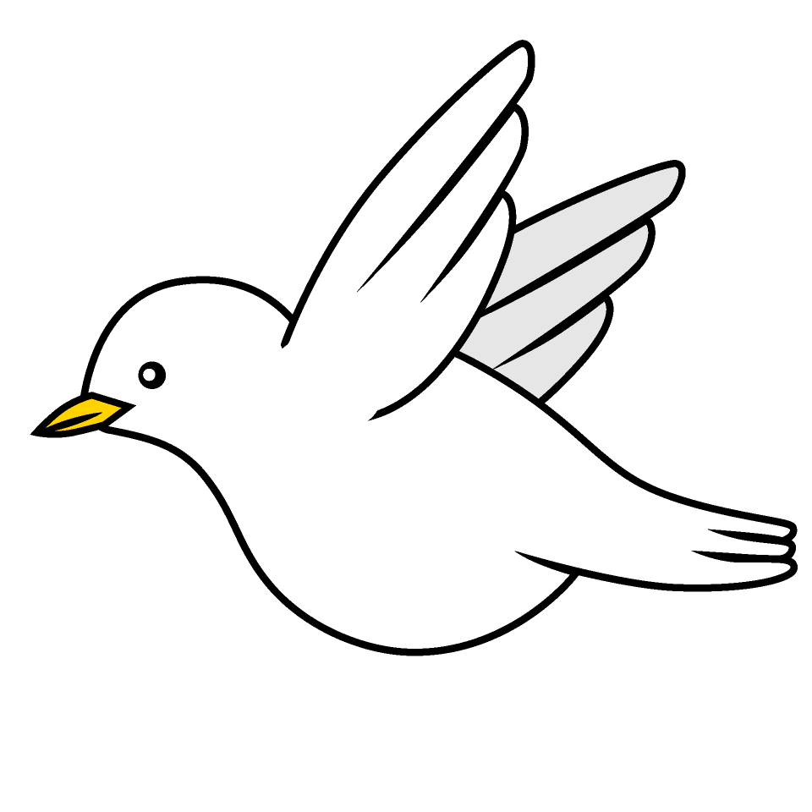
Tasks
Maths – Education City
Writing – Over the past couple of weeks we have been learning about instructions. Use your knowledge to write a set of instructions for how your made the cave paint that you made with Mrs Hicks in outdoor learning. Remember to include pictures or diagrams! Feel free to bring this into school to display in the classroom.
Reading – Read your school reading book at home and ask a grown up to write in your reading record. Try and read a little bit every night.
More books can be accessed through the website Oxford Owl.
Times tables -
Times tables rockstars https://ttrockstars.com/beta/
IDL - three sessions of IDL to be completed at home. Remember your username is your surname followed by the initial of your first name @ the school postcode eg boyds@fy67tf
Spellings – I will test the Common Exception Words for this term next week.

Use the common exception words list in the General Resources section of the home learning page begin learning the spellings highlighted in yellow for your year group.

