Doves Homework
11th November 2022
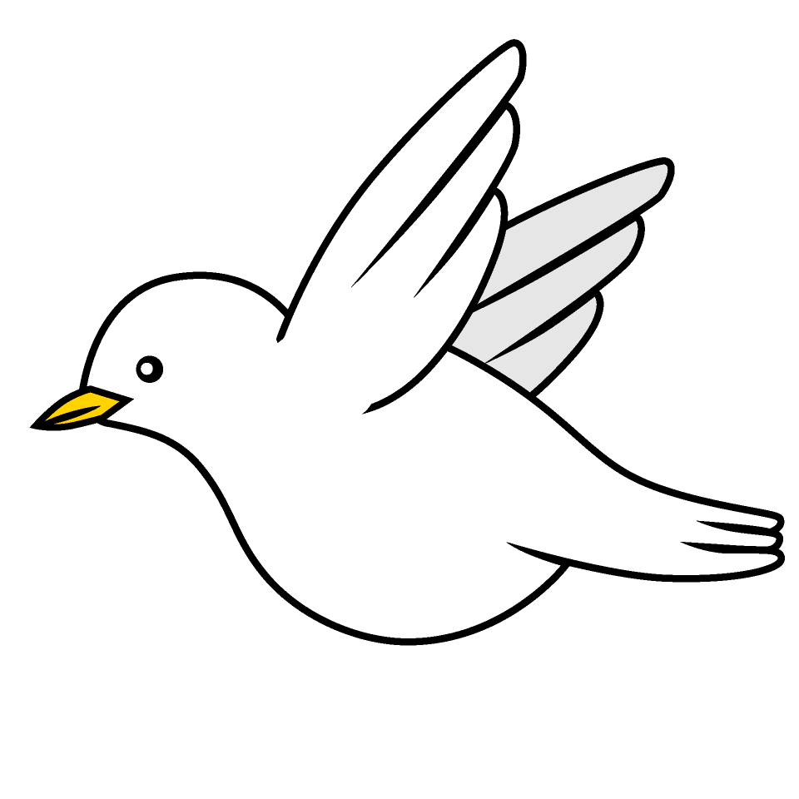

Tasks
Maths – Education City
Writing – We’ve been learning about sound in Science. Write me an explanation (with diagrams) about how sound works and travels to the ear and then ending up at the brain.
Reading – Read your school reading book at home and ask a grown up to write in your reading record. Try and read a little bit every night.
More books can be accessed through the website Oxford Owl.
Times tables -
Times tables rockstars https://ttrockstars.com/beta/
IDL - three sessions of IDL to be completed at home. Remember your username is your surname followed by the initial of your first name @ the school postcode eg boyds@fy67tf

Use the common exception words list in the General Resources section of the home learning page begin learning the spellings highlighted in yellow for your year group.

