Doves Homework
25th November 2022
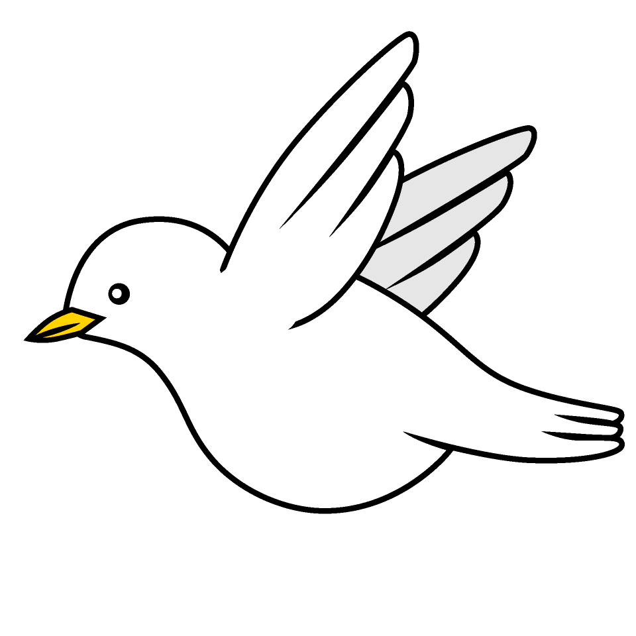

Tasks
Maths – Education City
Writing – Research a team that is taking part in the World Cup and produce a poster about that team and the country it is representing.
Reading – Read your school reading book at home and ask a grown up to write in your reading record. Try and read a little bit every night.
More books can be accessed through the website Oxford Owl.
Times tables -
Times tables rockstars https://ttrockstars.com/beta/
IDL - three sessions of IDL to be completed at home. Remember your username is your surname followed by the initial of your first name @ the school postcode eg boyds@fy67tf
Spellings -
Group 1: badge, sledge, village, cage, gem, energy
Group 2: dislike, dishonest, disobey, disagree, disappoint, discomfort
Group 3: action injection completion attention direction education invention
Group 4: expression discussion confession permission admission possession

Use the common exception words list in the General Resources section of the home learning page begin learning the spellings highlighted in yellow for your year group.

