Doves Homework
18th November 2022
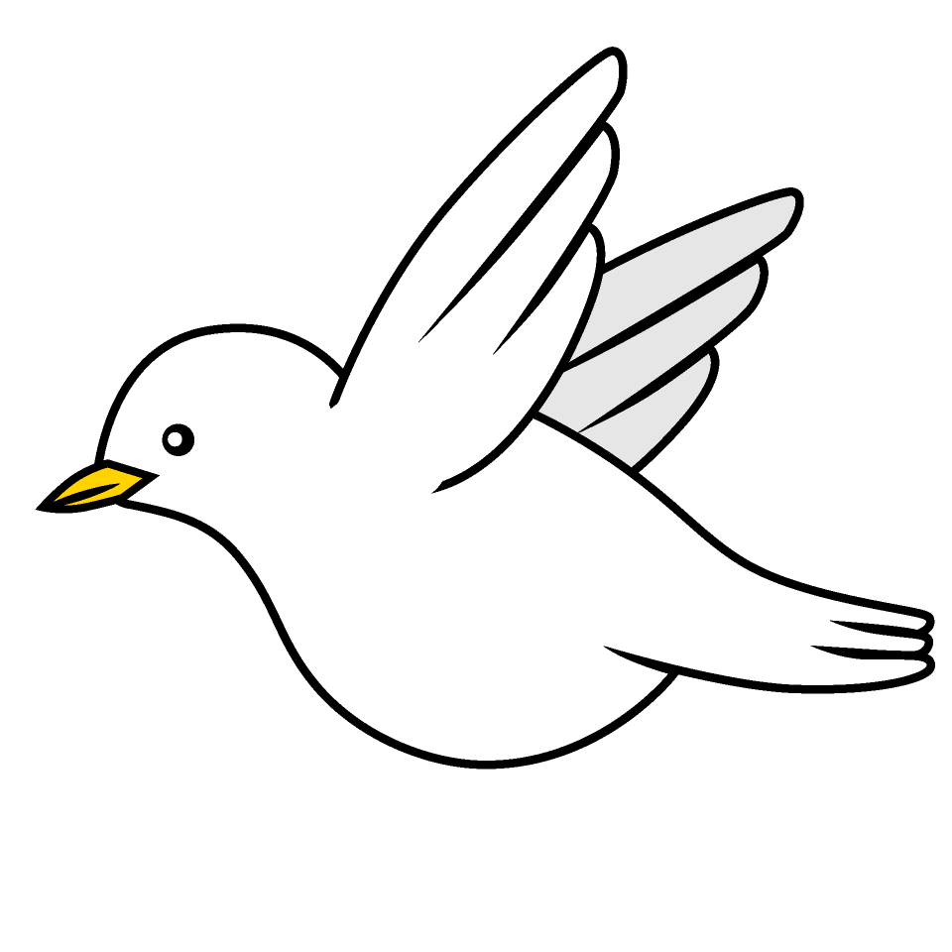

Tasks
Maths – Education City
Writing – Imagine you have travelled back in time to the Stone Age. Write a letter back to your family to tell them about your experiences. Use different conjunctions to extend sentences E.g. while, so, if, as… Use different sentence types e.g. statements, commands, exclamations and questions.
Reading – Read your school reading book at home and ask a grown up to write in your reading record. Try and read a little bit every night.
More books can be accessed through the website Oxford Owl.
Times tables -
Times tables rockstars https://ttrockstars.com/beta/
IDL - three sessions of IDL to be completed at home. Remember your username is your surname followed by the initial of your first name @ the school postcode eg boyds@fy67tf
Spellings -
Group 1: wrap wreck knock knight knit gnome gnaw sign
Group 2: unhappy unwell unclean unable unlucky unfasten untruthful unwanted
Group 3: division invasion decision collision television explosion
Group 4: expansion extension tension confusion transfusion supervision comprehension

Use the common exception words list in the General Resources section of the home learning page begin learning the spellings highlighted in yellow for your year group.

