Doves Homework
6th January 2022
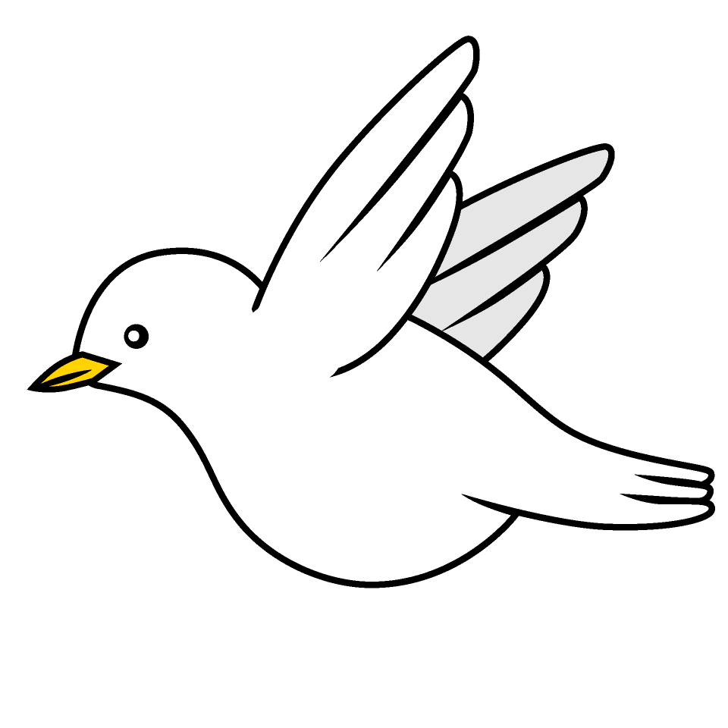

Tasks
Maths – Education City
Writing – Education City
Reading – Read your school reading book at home and ask a grown up to write in your reading record. Try and read a little bit every night.
More books can be accessed through the website Oxford Owl.
Times tables -
Times tables rockstars https://ttrockstars.com/beta/
IDL - three sessions of IDL to be completed at home. Remember your username is your surname followed by the initial of your first name @ the school postcode eg boyds@fy67tf
Spellings -
Group 1: hall, watch, come, wrote, design, fudge.
Group 2: redo, replace, dislike, disagree, misbehave, reappear.
Group 3: refresh, unclean, untruthful, misunderstand, action, couldn’t.
Group 4: decision, action, expression, permission, attention, mathematician.

Use the common exception words list in the General Resources section of the home learning page begin learning the spellings highlighted in BLUE for your year group.

