Doves Homework
13th January 2022
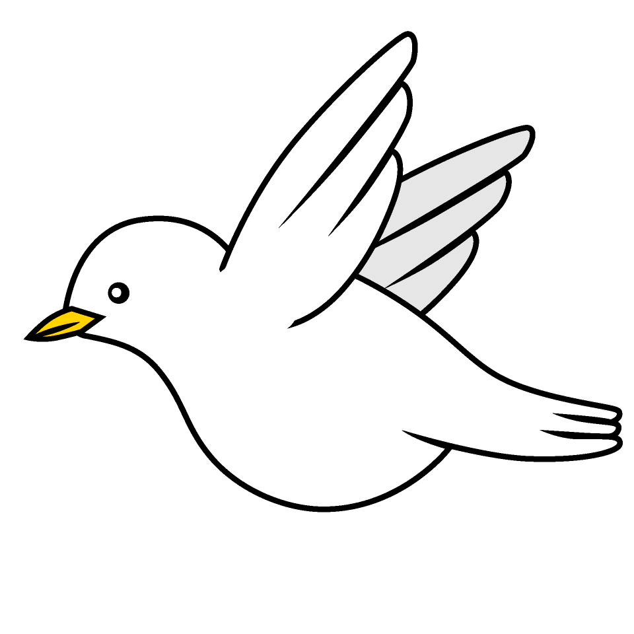

Tasks
Writing – Having read the first couple of chapters of Queen of Darkness. Can you write a description of what you think Boudicca is like? Think about the description of how she looks but also her personality.
Science – Education City
Reading – Read your school reading book at home and ask a grown up to write in your reading record. Try and read a little bit every night.
More books can be accessed through the website Oxford Owl.
Times tables -
Times tables rockstars https://ttrockstars.com/beta/
IDL - three sessions of IDL to be completed at home. Remember your username is your surname followed by the initial of your first name @ the school postcode eg boyds@fy67tf
Spellings -
Group 1: spy spies try tries parties fry fries
Group 2: superstar supercar supermarket superman superwoman supernatural
Group 3: babies thieves boxes flies catches cacti
Group 4: wolves potatoes libraries strength sentence straight strange

Use the common exception words list in the General Resources section of the home learning page begin learning the spellings highlighted in BLUE for your year group.

