Doves Homework
20th January 2022
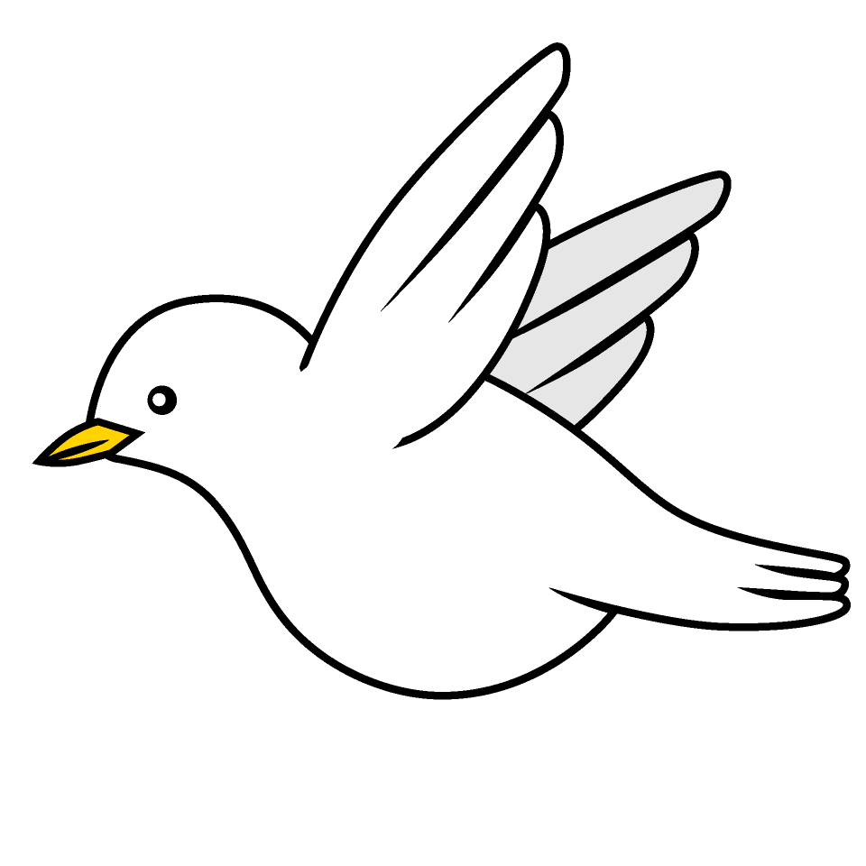

Tasks
Writing – Research & learn at least 5 facts about a Gladiator. Make a fact file about what their life was like. You could produce this as a poster, PowerPoint or a video!
Maths – Education City
Reading – Read your school reading book at home and ask a grown up to write in your reading record. Try and read a little bit every night.
More books can be accessed through the website Oxford Owl.
Times tables -
Times tables rockstars https://ttrockstars.com/beta/
IDL - three sessions of IDL to be completed at home. Remember your username is your surname followed by the initial of your first name @ the school postcode eg boyds@fy67tf
Spellings -
Group 1: wriggle nettle sizzle beetle table steeple
Group 2: antifreeze antisocial antiseptic anticlockwise subheading submarine
Group 3 & 4: ladies’ girls’ children’s pupils’ women’s boys’

Use the common exception words list in the General Resources section of the home learning page begin learning the spellings highlighted in BLUE for your year group.

