Doves Homework
27th January 2022
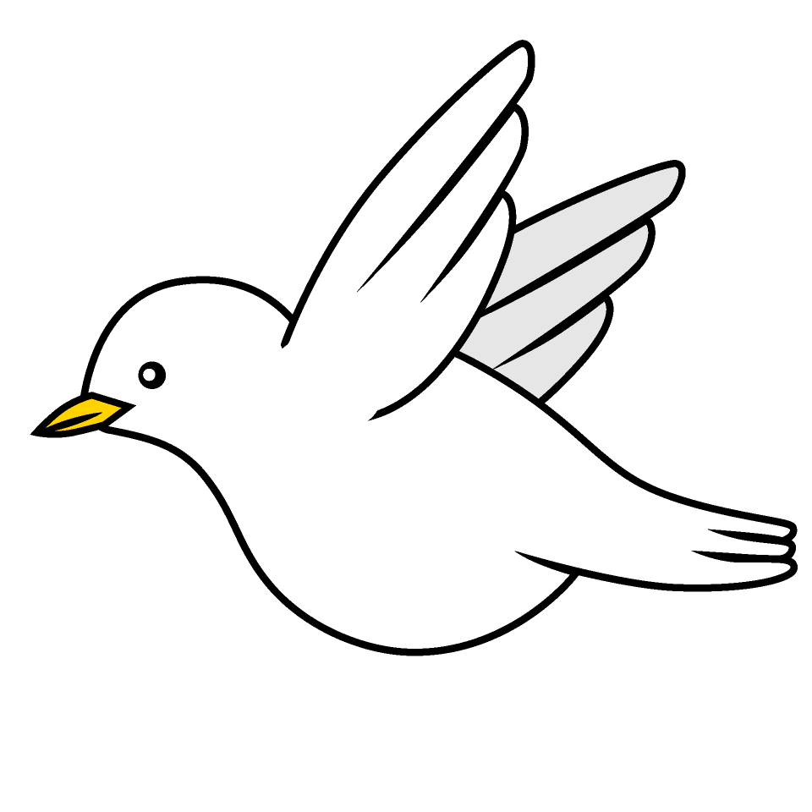

Tasks
Writing – Education City
Maths – Education City
Reading – Read your school reading book at home and ask a grown up to write in your reading record. Try and read a little bit every night.
More books can be accessed through the website Oxford Owl.
Times tables -
Times tables rockstars https://ttrockstars.com/beta/
IDL - three sessions of IDL to be completed at home. Remember your username is your surname followed by the initial of your first name @ the school postcode eg boyds@fy67tf
Spellings -
Group 1: medal capital hospital animal national fossil
Group 2: autograph automobile automatic subtitle supermarket superman
Group 3 & 4: forgetting forgotten beginning beginner preferred gardening

Use the common exception words list in the General Resources section of the home learning page begin learning the spellings highlighted in BLUE for your year group.

