Doves Homework
Friday 24th February 2022
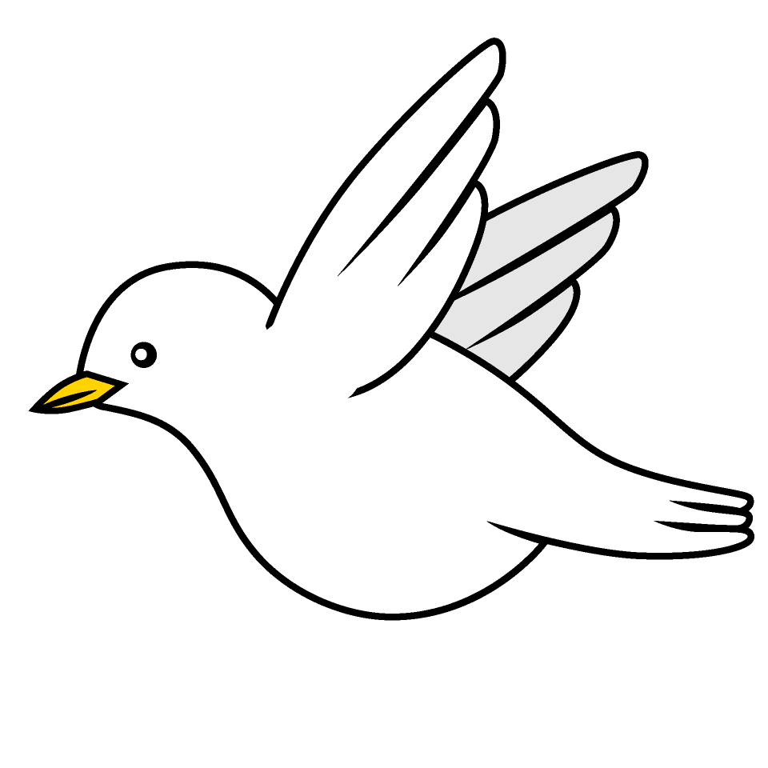

Tasks
Writing – Research an area of the Romans which you can use when you write your non-chronological report. Think about what sub-heading your information will need. Bring this into school on Friday.
Music – Access YuMu and have a go at as many of the activities as you can. If you forget how to login I have put some screen shots below or click on the link
Reading – Read your school reading book at home and ask a grown up to write in your reading record. Try and read a little bit every night.
More books can be accessed through the website Oxford Owl.
Times tables -
Times tables rockstars https://ttrockstars.com/beta/
IDL - three sessions of IDL to be completed at home. Remember your username is your surname followed by the initial of your first name @ the school postcode eg boyds@fy67tf
Spellings -
You will be tested on the blue common exception spellings for your year group next Friday.

Use the common exception words list in the General Resources section of the home learning page begin learning the spellings highlighted in BLUE for your year group.

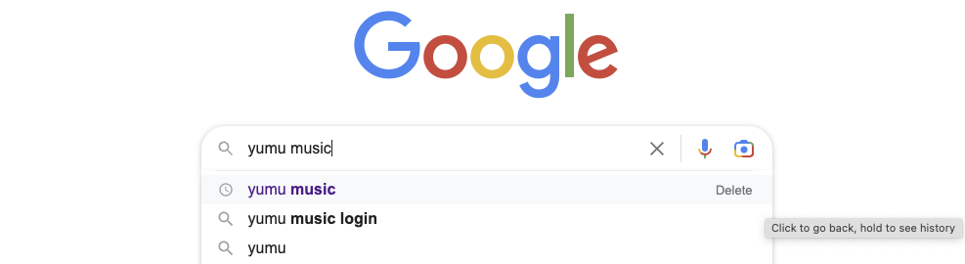
Google Yumu Music
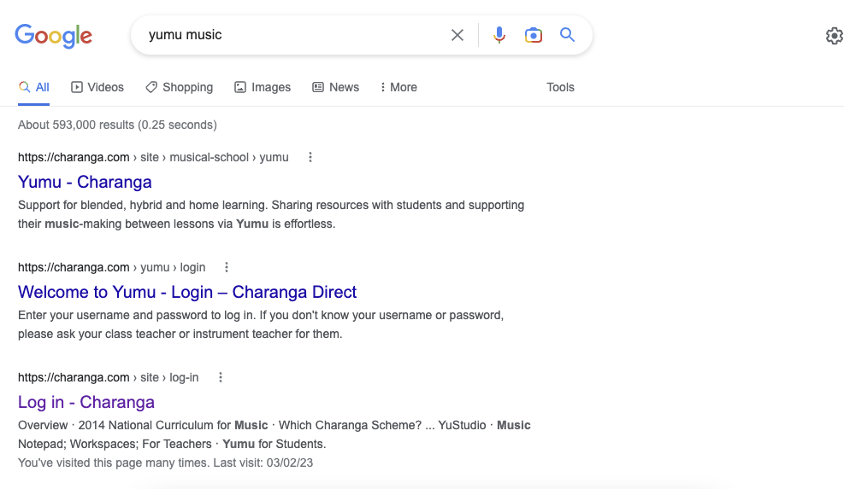
Choose the one that says login…
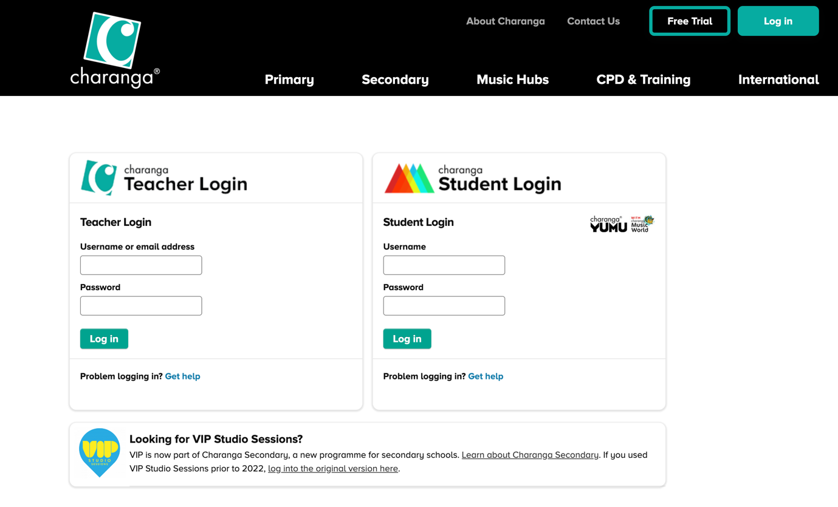
Enter details here…

