Doves Homework
Friday 24th March 2023

Tasks

Maths – Education City
If you have a part in our production, you need to learn your script!
Music – Access YuMu and have a go at as many of the activities as you can. If you forget how to login I have put some screen shots below or click on the link
Reading – Read your school reading book at home and ask a grown up to write in your reading record. Try and read a little bit every night.
More books can be accessed through the website Oxford Owl.
Times tables -
Times tables rockstars https://ttrockstars.com/beta/
IDL - three sessions of IDL to be completed at home. Remember your username is your surname followed by the initial of your first name @ the school postcode eg boyds@fy67tf

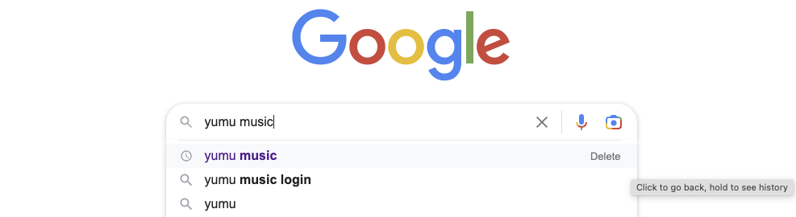
Google Yumu Music
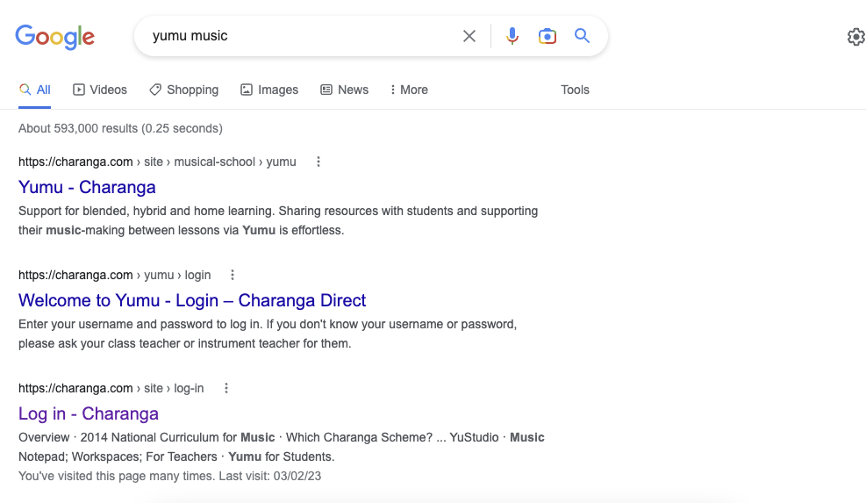
Choose the one that says login…
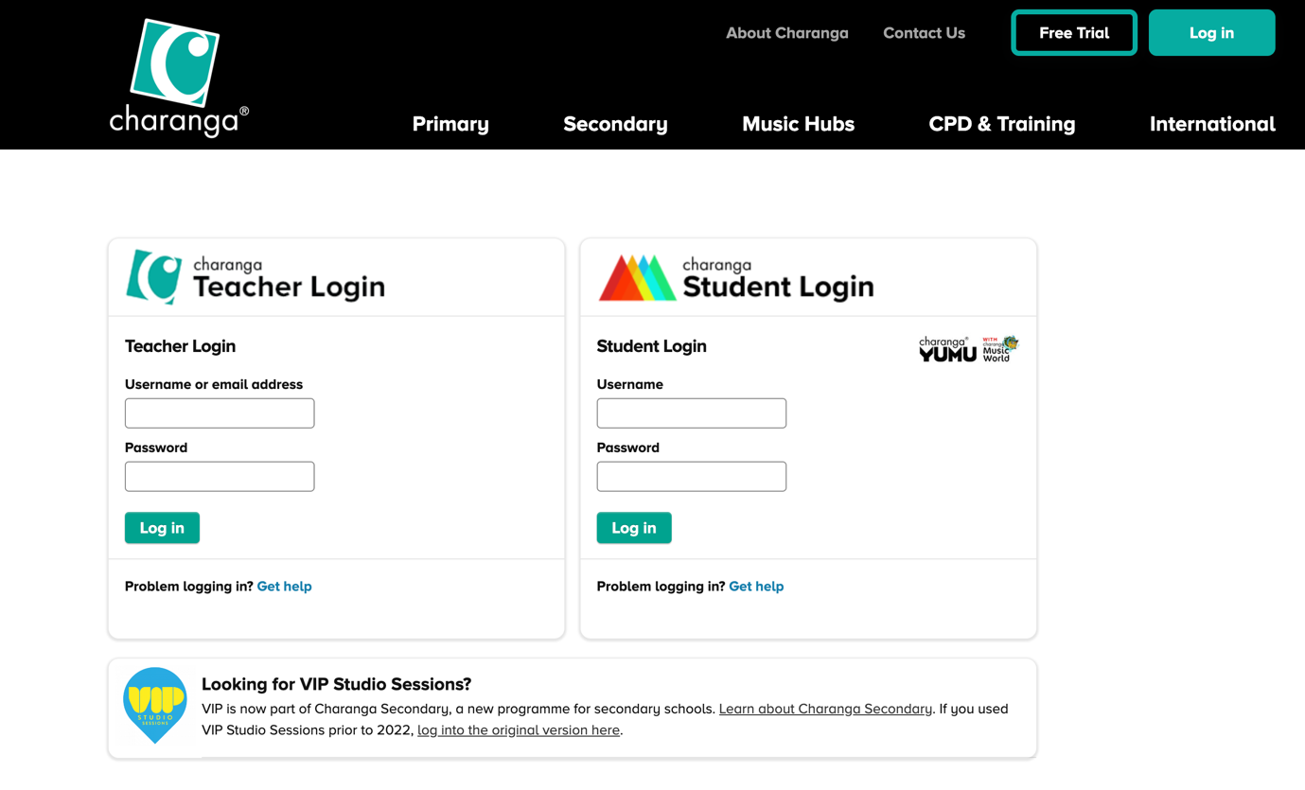
Enter details here…

