Doves Homework
Friday 28th April 2023
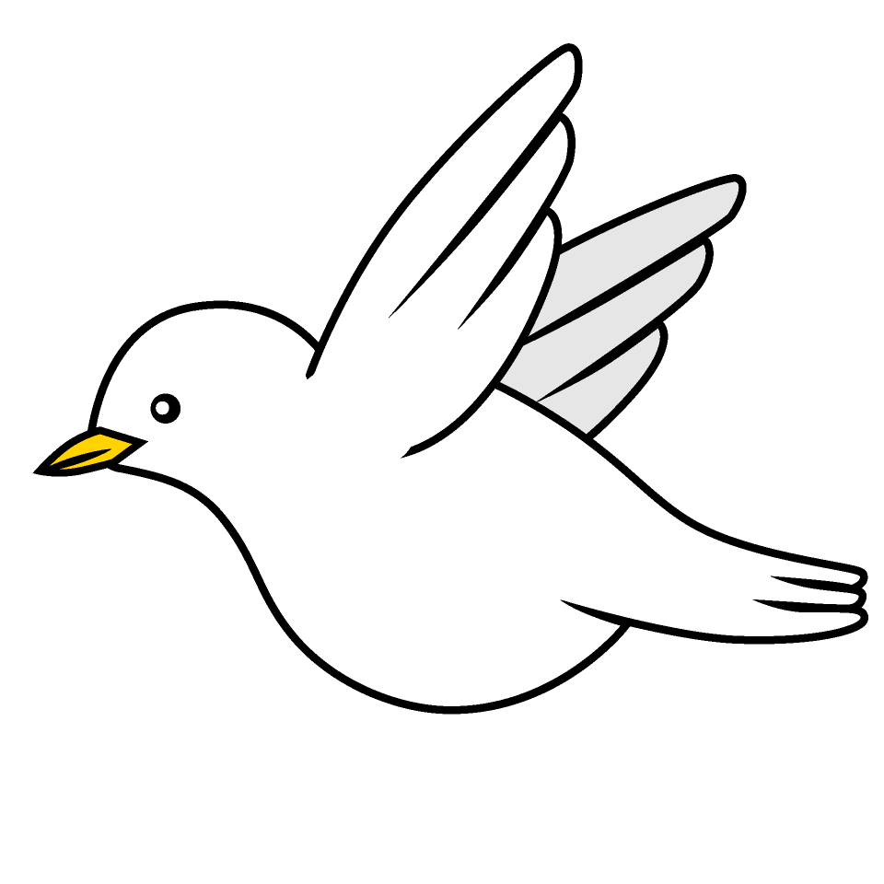

Tasks

Maths – Education City
English – Education City
Geography – Make a 3D model of a volcano. Can you include labels of the various parts eg crater, lava, magma chamber etc. This can be completed over the next couple of weeks and brought into school week beginning 15th May.
Music – Access YuMu and have a go at as many of the activities as you can. If you forget how to login I have put some screen shots below or click on the link
Reading – Read your school reading book at home and ask a grown up to write in your reading record. Try and read a little bit every night.
More books can be accessed through the website Oxford Owl.
Times tables -
Times tables rockstars https://ttrockstars.com/beta/
IDL - three sessions of IDL to be completed at home. Remember your username is your surname followed by the initial of your first name @ the school postcode eg boyds@fy67tf

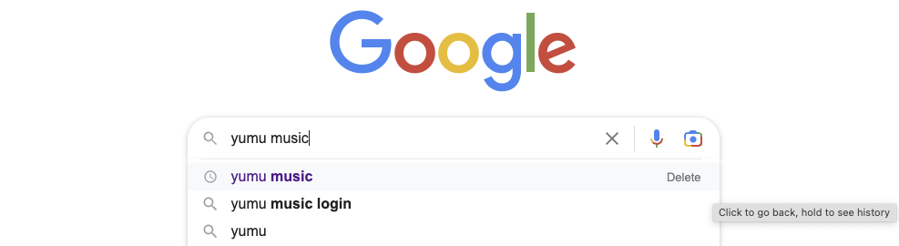
Google Yumu Music
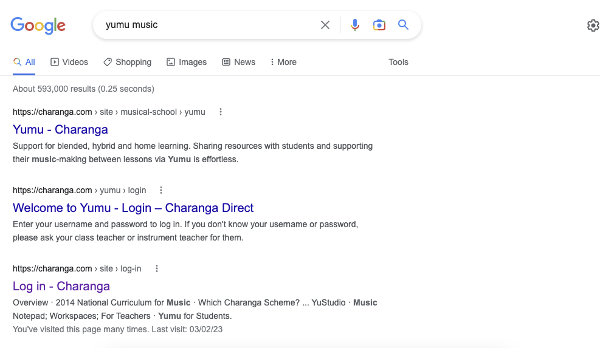
Choose the one that says login…
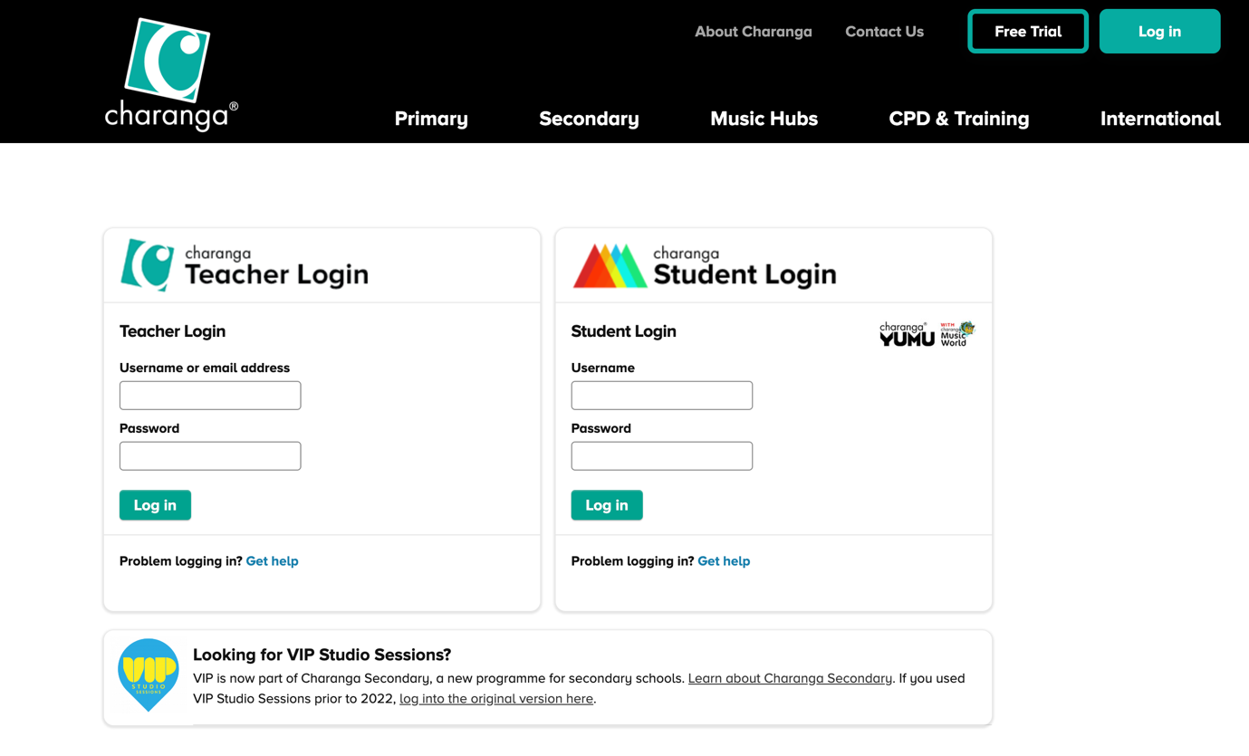
Enter details here…

