Talk for Mathematics

Recap over areas we have noticed need re-visiting more regularly from our end of term quiz, such as....
- Look at or find objects and compare their length, size and weight, using the comparative vocabulary - longer, longest, lighter, lightest, etc, Make some balance scales to see which side of the scales is heavier or lighter and what happens to that side.
- Find real-life examples of 3D shapes around the home,especially where the shape might be longer and thinner or shorter and wider than they might usually see this shape! Cylinder, cube, cuboid, cone, pyramid, triangular prism

- Explore and find all of the pairs of numbers (number bonds/pairs) different ways to make 5 and 10. Use any house hold objects. Make a ten frame or five frame with masking tape to help you or chalk a 5 or 10 frame outside.
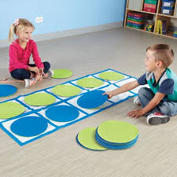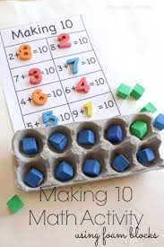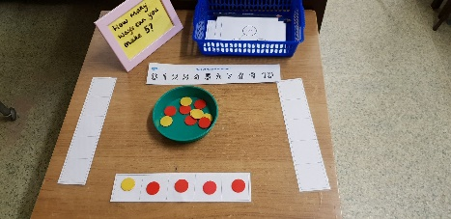
Download the new White Rose - 1 minute maths games app to play and practise basic number skills.
https://whiterosemaths.com/resources/1-minute-maths
www.ictgames.com/numeracy
www.topmarks.co.uk
Practise your number formation.
{doc:210108221235-cc400a3169ed93a578a002b8613e180a}
Talk for Reading and Writing
**Please aim to try and read every day!!**
Play the phonics games sent home together.
Use the digraph cards sent home to practise reading simple words and make words with these in - ar and or.
Practise writing these digraphs in sand, with chalk on the path or in the mud with a stick!
Look for these digraphs in books at home.
Chalk a hopscotch outside with all of the sounds you are learning in. Jump on and say each sound/phoneme.
Watch Geraldine the Giraffe (+ the digraph ar and or) youtube phonics clips.
Watch the Silly School videos for the ar and or digraphs - https://youtu.be/IL0hguTSVLo https://youtu.be/xnVRH_v7ovY
Read the decodable comics on Phonics Play https://phonicsplaycomics.co.uk/comics.html
Watch and join in with the tricky word songs https://youtu.be/R087lYrRpgY https://youtu.be/ri4u0TjAZ38 https://youtu.be/VzpAJVE0OW8
https://youtu.be/yM11q1yIdPM https://youtu.be/t_D69emGgTM
Write sentences with the tricky words in or look for them in your reading books.
Practise writing the tricky words with chalk outside. Make a hopscotch!
Make a tricky word treasure hunt around the house using post-it notes with tricky words written on. Can they find them and say them?
Play the tricky words games that have been sent home.
www.phonicsplay.co.uk
www.phonicsbloom.co.uk
Talk for Topic
Tell your family some facts that you have learnt about different dinoaurs.
Explain who Mary Anning was and what she did.
What do you think made all of the dinosaurs extinct?

