Home Learning 26.5.23
Visit https://www.educationcity.com/ to access some additional homework ideas.

Talk for Mathematics - Doubling
Get some dominoes and look for doubles. What total do they make? Say the number sentence - 1+1=2, double 1 is 2.
Look for different dominoes that make a double but are not identical, for example 1+2=3/3+0=3, double 3 is 6.
Roll a dice and double the number!
Draw some ladybirds with a double number of spots on. Write or say the number sentence!
Sing the doubling songs....
https://www.youtube.com/watch?v=M9YQ4phTB0E and https://www.youtube.com/watch?v=8jOzhiACB68

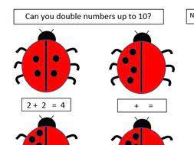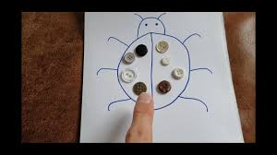
Make a paper chain train! Double the number of 'carriages,' say the number sentence each time.
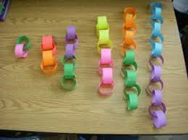
Download the new White Rose - 1 minute maths games app to play and practise basic number skills.
https://whiterosemaths.com/resources/1-minute-maths www.ictgames.com/numeracy www.topmarks.co.uk
Practise your number formation.
{doc:210108221235-cc400a3169ed93a578a002b8613e180a}
Talk for Reading and Writing
**Please aim to try and read every day!!**
Play the phonics games sent home together.
Practise all of the digraphs, trigraphs and tricky words that we have been learning this term, especially any that your teacher has indicated that you need to practise further.
Practise writing these digraphs/trigraphs in sand, with chalk on the path or in the mud with a stick!
Look for these digraphs/trigraphs in books at home.
Chalk a hopscotch outside with all of the sounds you are learning in. Jump on and say each sound/phoneme.
Watch Geraldine the Giraffe (+ the sounds air, ure, and er) youtube phonics clips.
Watch the Silly School videos for the oi and er digraphs and the trigraph air - https://youtu.be/CdC72XSMuoc https://youtu.be/8Tqh_9VGq6o https://youtu.be/Eh0ZhoOLAMU
Read the decodable comics on Phonics Play https://phonicsplaycomics.co.uk/comics.html
Watch and join in with the phase 2/3 tricky word songs https://youtu.be/R087lYrRpgY https://youtu.be/ri4u0TjAZ38 https://youtu.be/VzpAJVE0OW8
https://youtu.be/yM11q1yIdPM https://youtu.be/t_D69emGgTM
Phase 4 Tricky words https://youtu.be/3NOzgR1ANc4
https://youtu.be/brBjwnJHvek https://youtu.be/OrwjbulJry4
Write sentences with the tricky words in or look for them in your reading books.
Practise writing the tricky words with chalk outside. Make a hopscotch!
Make a tricky word treasure hunt around the house using post-it notes with tricky words written on. Can they find them and say them?
www.phonicsplay.co.uk
www.phonicsbloom.co.uk

Talk for Topic
When you are travelling about at half-term, look through the window and describe what you can see in different places.
What can you see in a town or a city? The countryside or at the seaside?
What do you see/find in different environments, such as the beach, the woods, on a hillside?
Draw a map of any journeys you have taken this holiday and bring them in to show the class on our return.

