40 Fine Motor Skills Activities

Here is a collection of 40 fine motor skills activities for young children that are easy to set up and promote a whole range of skills. They’re creative, open-ended, appropriate and varied with ideas for practising motor skills through art, sensory play and simple manipulative games, and there are so many to choose from!
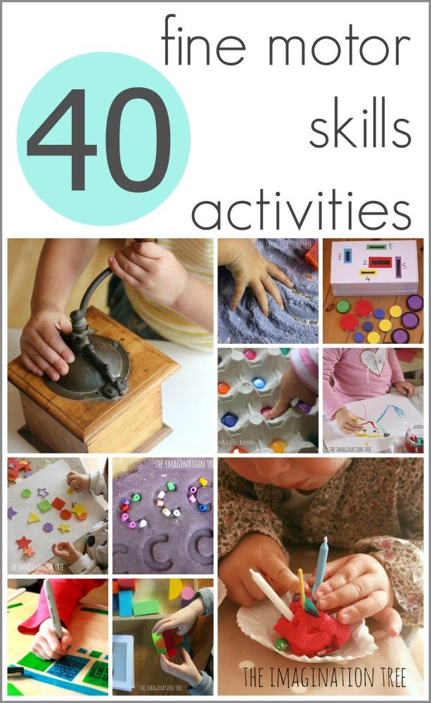

One of the most important ways we can help our children while playing with them at home or in a childcare/ classroom setting is through setting up simple activities that help to develop fine motor skills. Young children need to be able to hold and use scissors and pencils appropriately before using them in a classroom context. We cannot expect them to be able to write if they haven’t yet developed the strength needed in their hands and fingers.
There are plenty of easy ways to strengthen these muscles, practise co-ordination and develop hand:eye co-ordination using simple, everyday materials and a bit of creative fun! Here are 40 that we have done over the past few years with babies to 5 year olds. There are a million variations you could make from each of these to cater for your own child’s particular interests and learning dispositions. Use these as a springboard and pin it for future reference too!
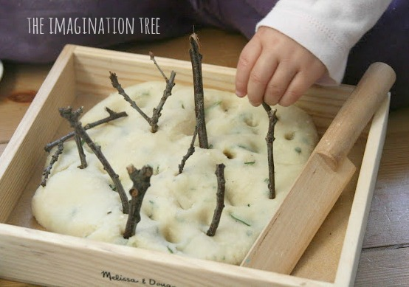

[Herbal play dough with natural materials to explore]
My personal favourite tool for developing all fine motor skills is the humble ball of homemade play dough. It can be used in SO many ways by adding other combinations of materials to it, and automatically strengthens little hands as they roll, squeeze, twist and build with it. Here is a whole post about the benefits of playing with play dough and a handy guide to starting out with building your own play dough tool kit. Of course, baking with real dough is another wonderful way to play and learn simultaneously!
The many benefits of play dough (and a tool kit)
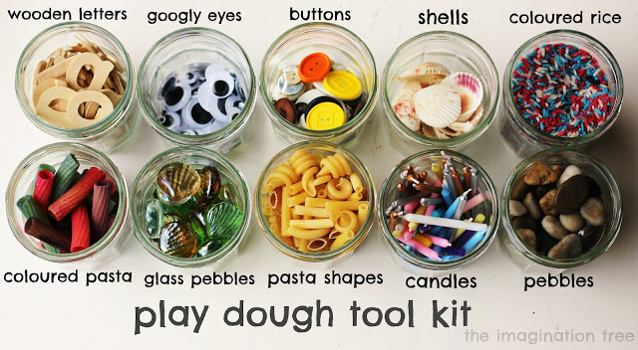
Other activities we have loved have included exploring sensory play materials, transporting small parts, threading beads, hands-on art projects, cutting and sticking, tearing and scrunching papers, opening and closing fastenings and countless others. Here is a selection of some of those favourites, all of which can be adapted for different age groups and abilities.
Threading with beads onto pipe cleaners
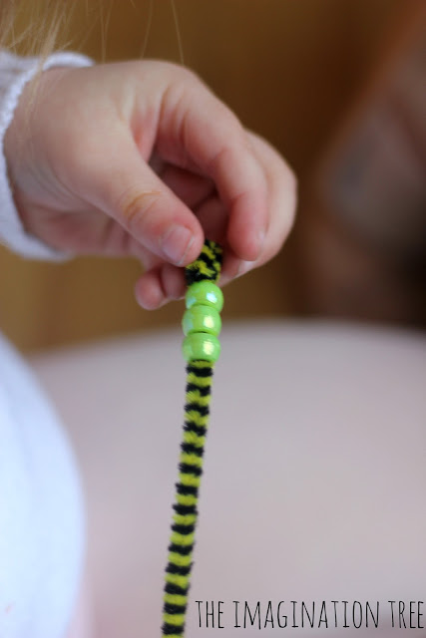

Threading, posting and slotting toys for babies and toddlers
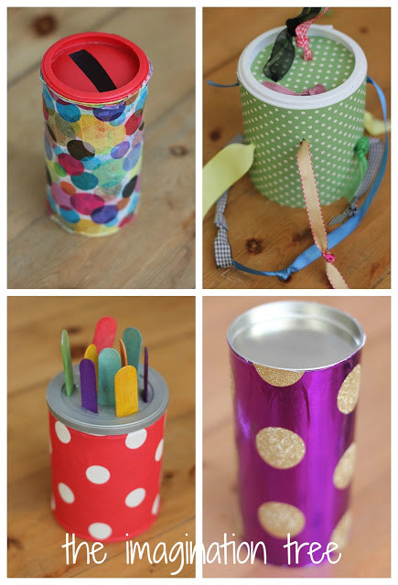
Poking straws into holes
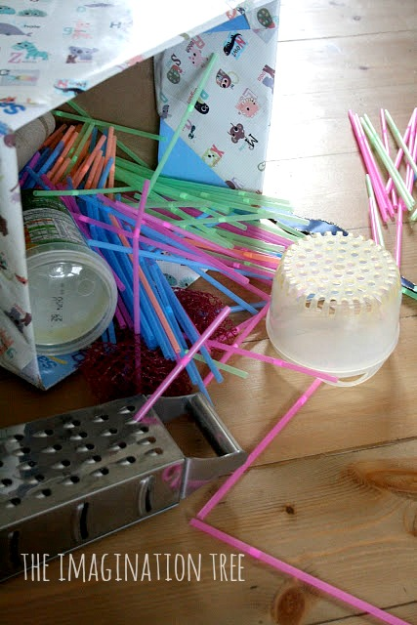
Pasta necklaces
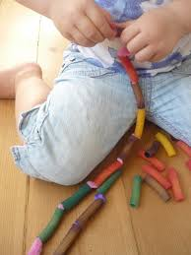
Monster play dough
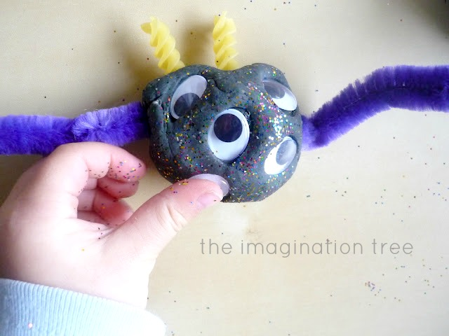
Weaving around cardboard
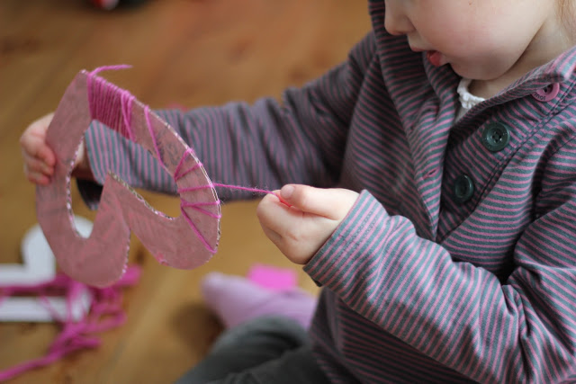
Fairy sparkle playdough
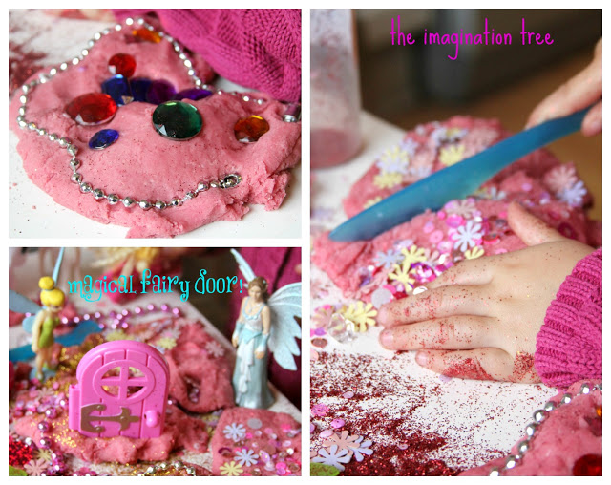
Pipe cleaners and colanders
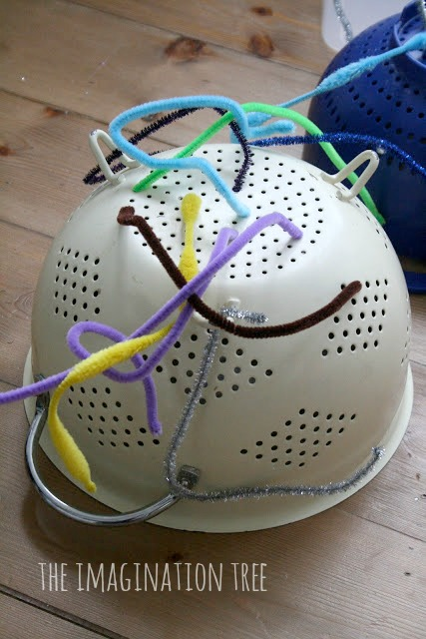

Beads on spaghetti
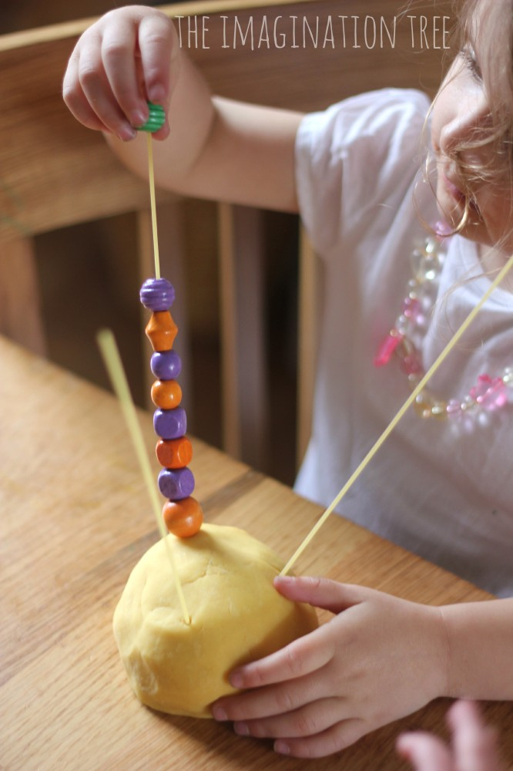
Hair rollers sticky construction
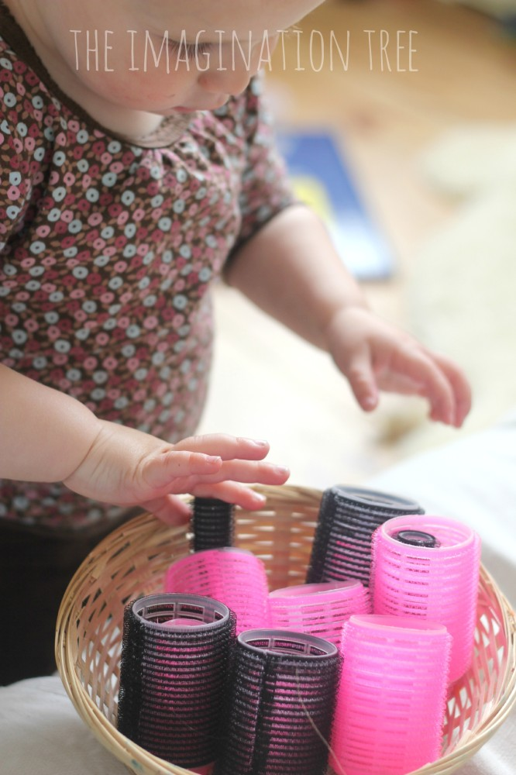

First sewing basket
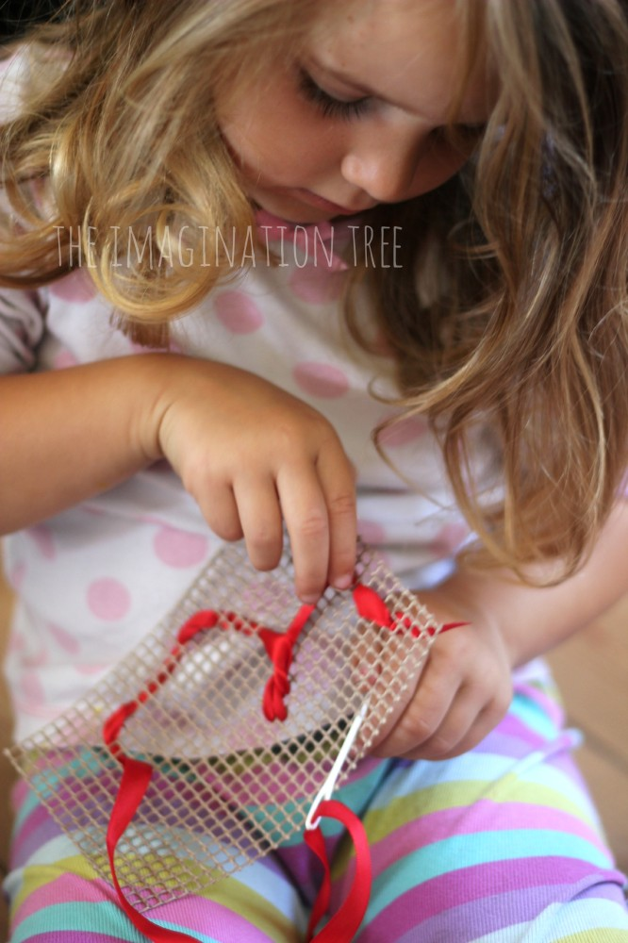
Edible finger painting
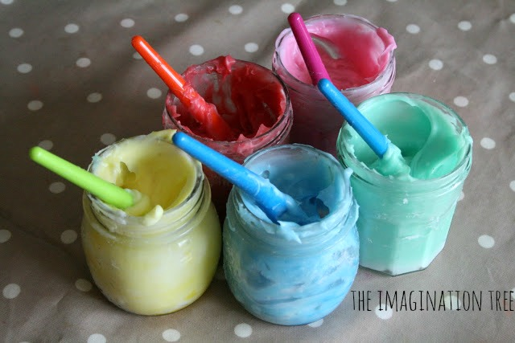

Making marks in fairy dust
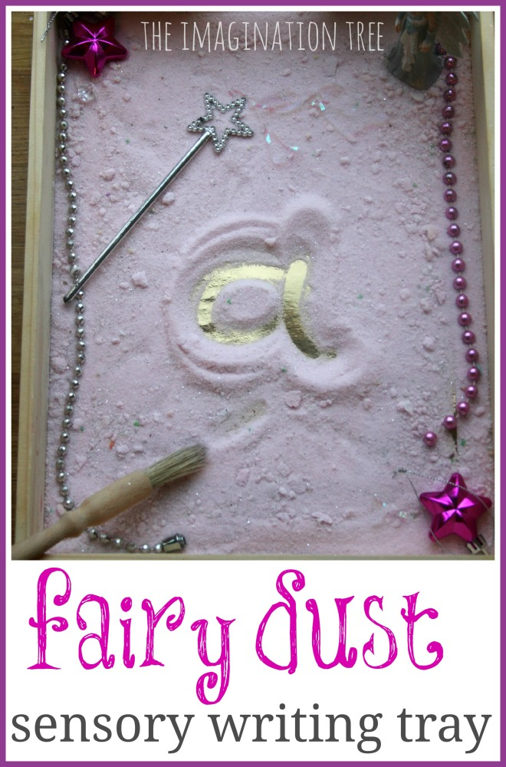
Decorating play dough eggs
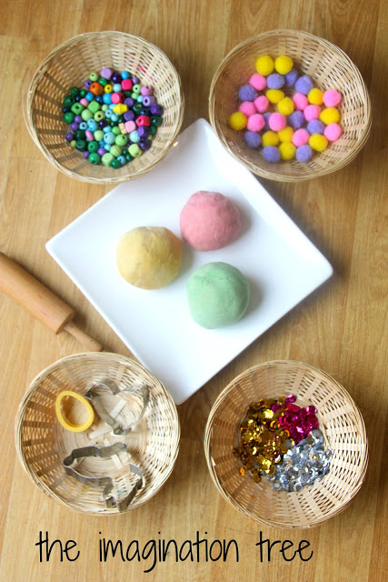
Mark making and scooping in lavender sensory salt
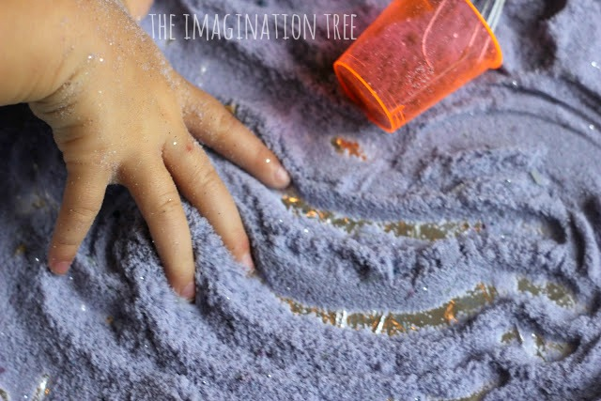
Building 3D models
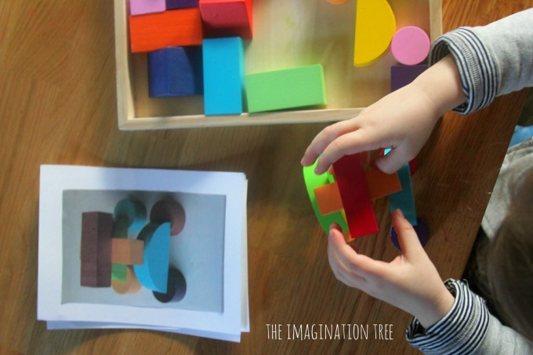
Sorting and pattern making with shells
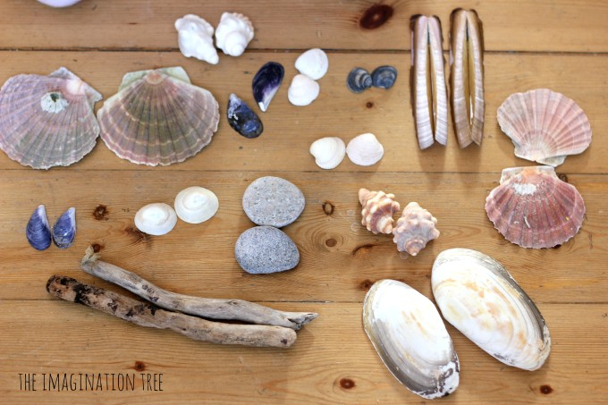
Patterning with lego
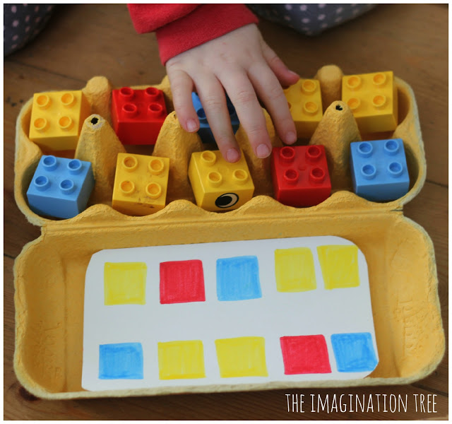
Lid posting game
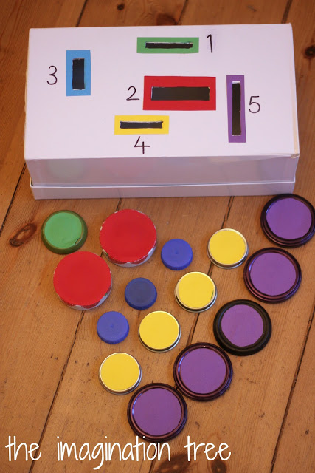

Snipping and doodling sticky stained glass windows
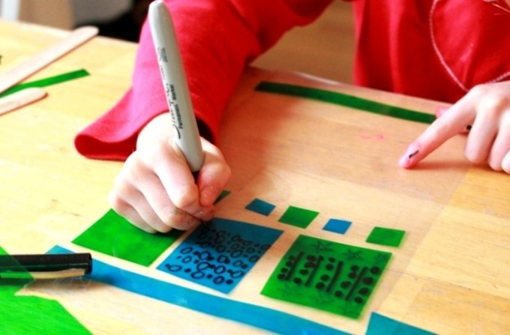
Whisking up coloured sensory soap
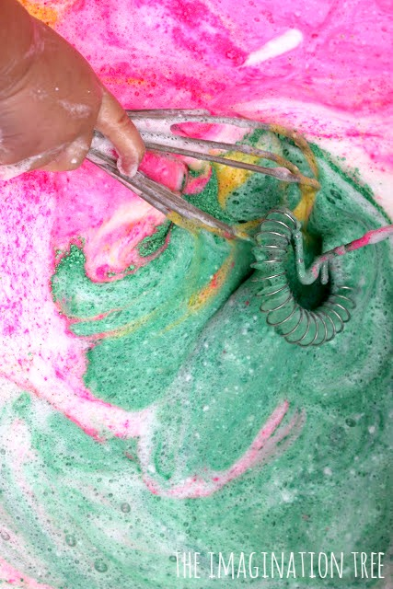

Salt dough alphabet modelling
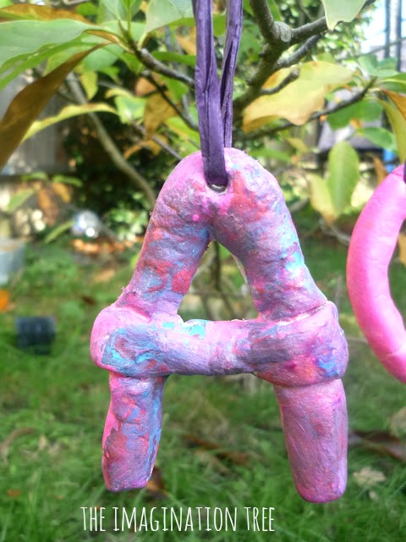
Pebble sorting
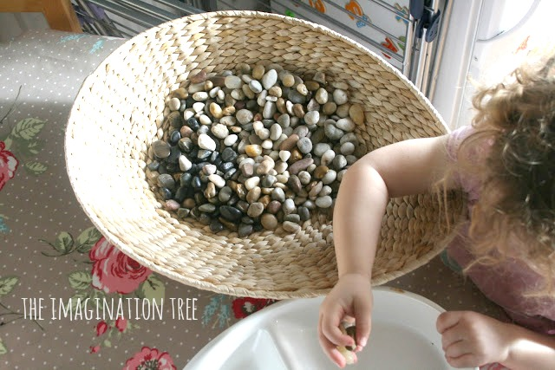
Stacking cups
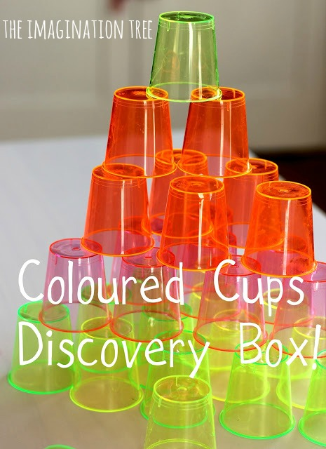

Play dough cupcakes
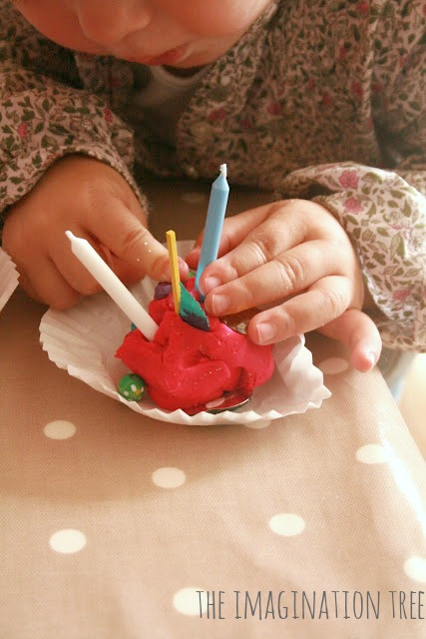
Foam and water window art
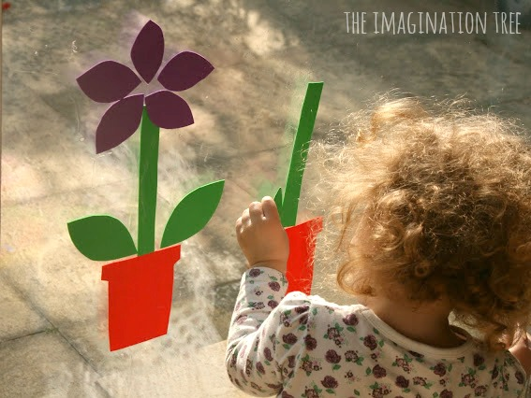
Pom pom drop game
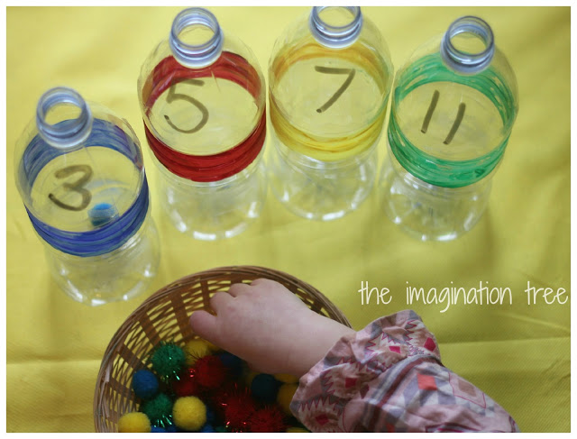

Painting with water
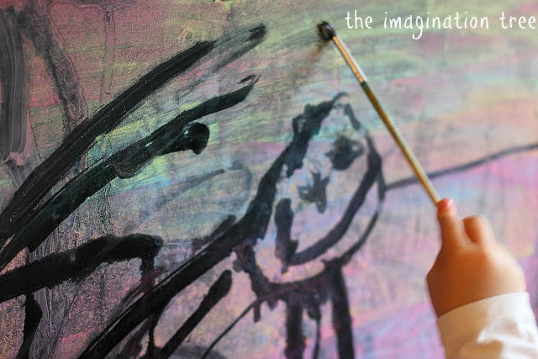
Finger paint mono-printing
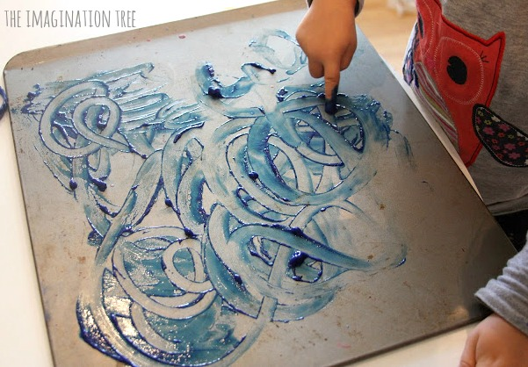
Matching lids game
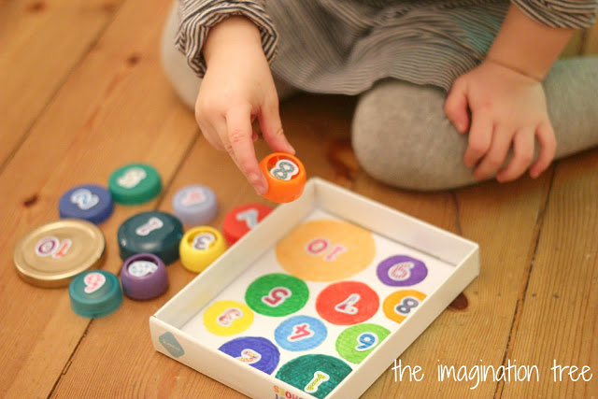
Painting with Q-tips
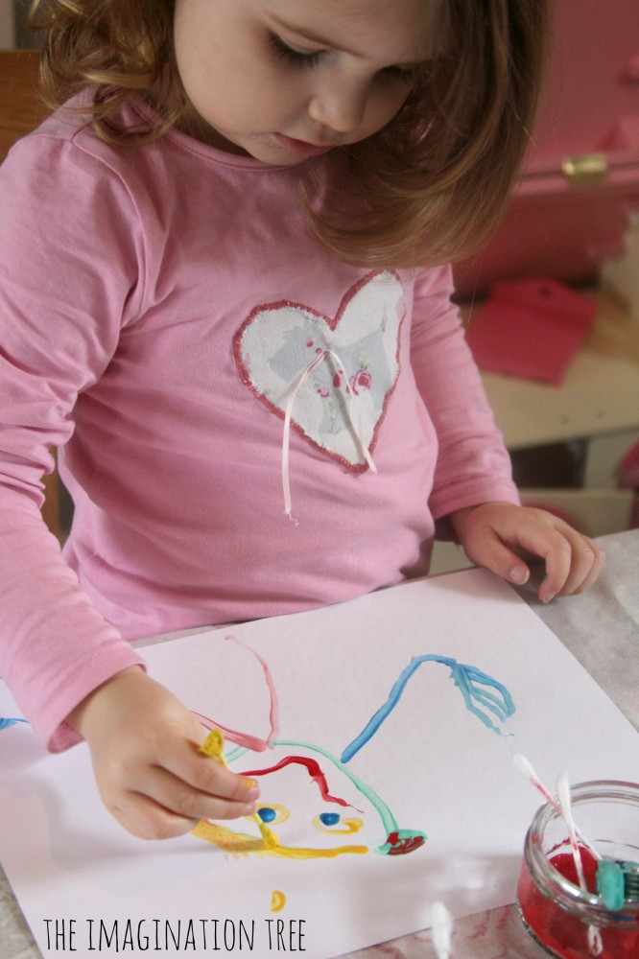
Tape resist paintings
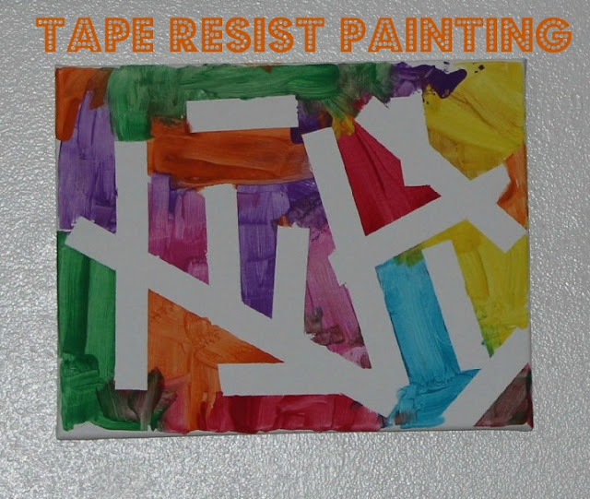

Tinkering with wires and loose parts in play dough
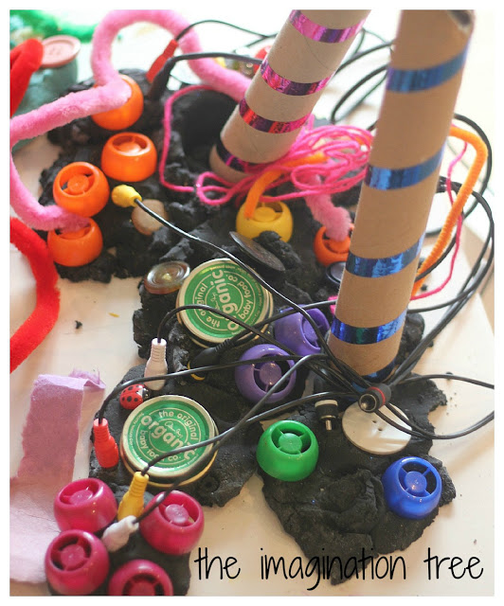

Grinding coffee beans
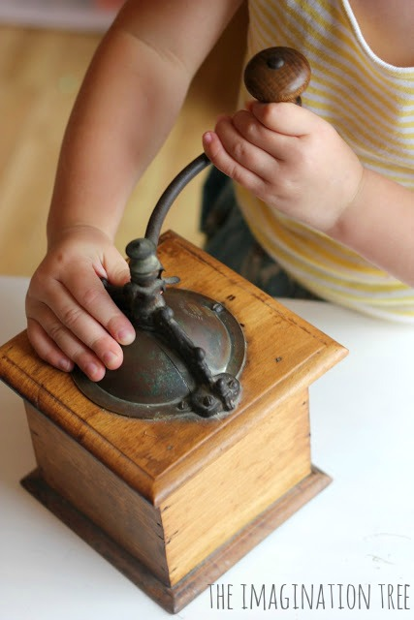
Sorting coloured chips in egg cartons
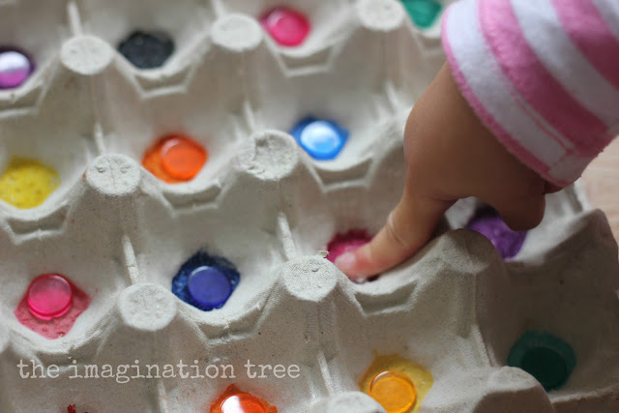
Tearing and sticking collage
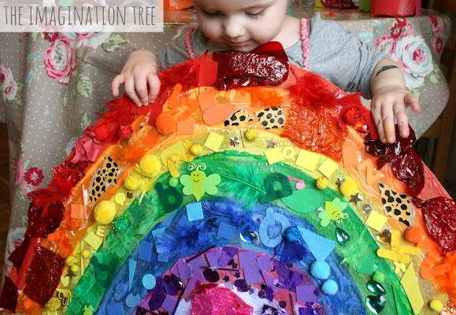
Paper bag weaving
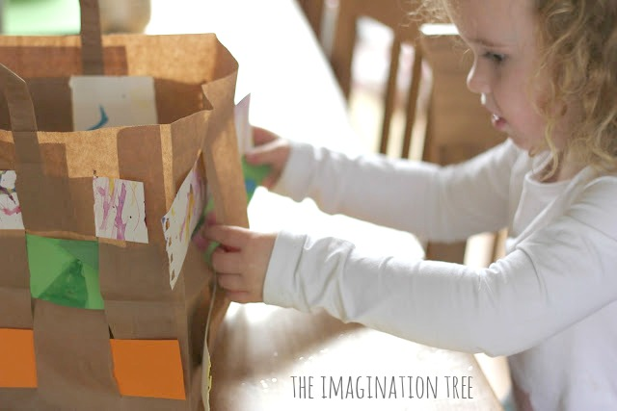
Sticker and felt collage
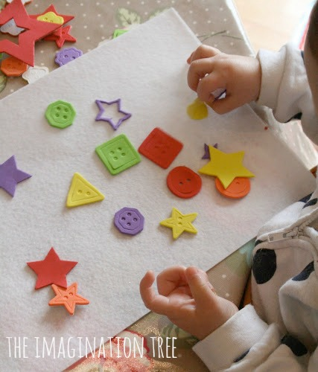
If you would like some more ideas for making play dough exciting, here are over 50 in this round up collection, all from this blog!


