Dates remaining for this term:
Owls’ Class Assembly ~ Tuesday 28th November 15:00-15:25
2nd Parent Forum ~ Monday 4th December. 18:00-19:00.
Friday 8th December ~14:30-15:30. Open afternoon to share how we carry out Guided Reading sessions in school.
Little Chicks’ and Ducklings’ Nativities ~ Tuesday 12th December at 09:30, 14:00 and Wednesday 13th December at 09:30
Years One and Two Christmas Productions ~ Thursday 14th December at 14:00, 18:00 and Friday 15th December at 09:30.
Christmas Lunch will take place on the 19th December.
Christmas Candlelit Carol Service ~ 19th December from 18:00 at Rossall Chapel. Please bring your children at 17:30 even if you are unable to stay. Every child has a part to play.
Christmas Market ~ Thursday 21st December at 15:00 -17:00 in our large playground or hall if raining.
End of Term Friday 22nd December at 14:30.
Please keep looking at the dates section as we will be adding information.
Any amendments will be highlighted in red.

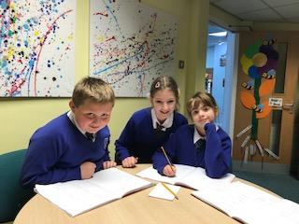
Fabulous Mathematicians!
I really enjoyed seeing Harry, Ava and Elsie this week where they were excited to share their learning about percentages!

We had a brilliant turn out for the Doves’ Class assembly this week – I know Mrs Harding and her class were thrilled to have so many families support their work.
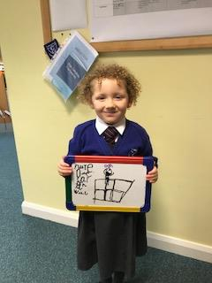
Lola-Rose came skipping to my room to show off her brilliant writing. She thought about all the sounds in the words and had even drawn a picture! So impressed!

The Parent Forum this half term is scheduled to take place on the 4th December from 18:00-19:00. We are to discuss the way we organise our classes across school, our music provision and after school activities. The aim of this evening is for us to actively work together to share ideas to improve further what is currently taking place. I really hope that you will feel this to be a beneficial use of your time and join us.

Farren Ansell, Euan McGuinness, Keisha Rigby, Amy Atherton, Adam Rogerson, Abbie Wood, Summer Way, Jacob Turner, Isabelle Michelbach, Hunter Whyte and Leo Dixon.

We have experienced extreme weather conditions this week but despite a few leaks and a flooded field we were fortunate to be able to remain open. We hope that you have all managed to say safe and warm. The weekend is set to have more rain so we all need to be prepared.

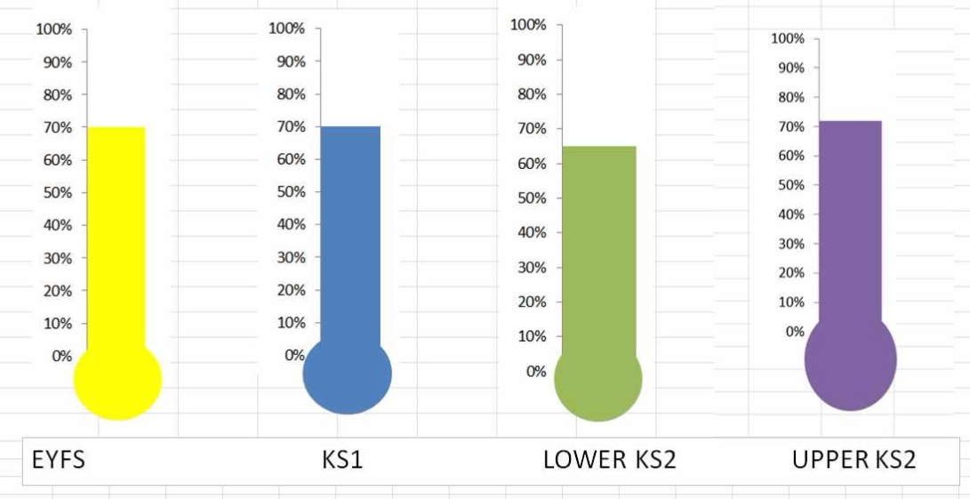

If you haven’t already please could you make your trip payments via parent pay or cheque?
Ducklings ~ £20 contribution per child
Parrots, Herons and Robins ~ £22 contribution per child
Kestrels, Doves and Owls ~ £24 contribution per child
Falcons, Hawks and Eagles ~ £30 contribution per child
https://www.parentpay.com/public/client/security/#/login or pay via a cheque.
Yellow Ducklings  99% with 0 lates | Brown Ducklings  98% with 1 late | Parrots  95% with 0 lates
Herons  98% with 0 lates | Robins  98% with 2 lates | Owls  90% with 4 lates
Kestrels  94% with 0 lates | Doves  95% with 3 lates | Falcons  97% with 3 lates
Hawks  92% with 6 lates | Eagles  98% with 0 lates | Well done to those for making it to school every day on time!

Thank you for all your continued support for all that takes place inside and beyond school.
Susan McGrath
Headteacher.

