Dates for the Summer Term:

4th May ~ Falcons, Hawks and Eagles open afternoon 14:15 – Home time. Please come through the playground to your child’s normal door into school.

5th May ~ Kestrels, Doves and Owls open afternoon 14:15-Home time. Please come through the playground to your child’s normal door into school.

Week Beginning the 9th May ~ Year Six SATs

Friday 13th May ~ Year Six’s may start to wear Leavers’ Hoodies

Week Beginning 16th May ~ Year Two assessments.

Wednesday 18th May ~ New Induction Evening to welcome our new parents to school for September.

Monday 23rd May ~ Sports’ Day. Whole school from 13:30 (weather dependant)

Tuesday 24th May ~ Stay and Play for our new Ducklings. Families invited to tea and cake in The Wing. 15:40-16:30.

Week beginning the 23rd May ~ Healthy Living Week

Friday the 27th May ~ Break up at 15:30 for half term holiday.

Year 5’s to write a letter to the Headteacher outlining their desire to be considered as a Head or Deputy Leader in our school. These letters are to be posted to school by 6th June.

Week Beginning the 6th June ~ Year One Phonics tests

Tuesday 7th June ~ Stay and Play for our new Ducklings. Families invited to tea and cake in The Wing. 15:40-16:30.

Week Beginning the 13th June ~ Year Four Multiplication Check

Week beginning 20th June ~ Year Five Outdoor Adventure Days. Information about this trip was emailed out on the 28th April.

Wednesday 29th June ~ Years 5 and 6 end of year production.

Thursday 30th June ~ Summer Fair from 13:30 – 17:00. More details to follow.

Friday 1st July ~ Additional bank holiday for the Queen’s Jubilee

Week Beginning the 4th July ~ Transition to new classes.

Thursday 7th July ~ Little Chicks’ Graduation at 14:30

Week beginning 11th July ~ Year Six residential trip to Waterpark!!!!!

Wednesday 20th July ~ Leavers’ Assembly and BBQ 17:30-21:00.

Friday 22nd July ~ Year 6 Glo-Dodgeball in the morning.

Friday 22nd July ~ Heads and Deputies are announced with Star of the Year Assembly 13:30-15:00.
Finish for the summer holidays.

^{This week’s stars are:}
Yellow Ducklings ~ Jacob W, Brown Ducklings ~ Rodney M, Herons ~ Elizabeth Mc, Parrots ~ Eva S, Robins ~ Cole S, Kestrels ~ Rory S, Doves ~ Holly P, Owls ~ Lexie P, Falcons ~ Isabelle M, Hawks ~ Blake I and in Eagles ~ Tarek H

We are thrilled to learn that Zachary T has been selected to be the prince of Poulton Gala, as part of the Gala Queen's retinue.

Poulton Gala is on Saturday 28th May and is space themed this year.

Poulton Gala needs your help:
“We need volunteers for marshalling, it involves giving a maximum of 2 hours of your time and you will still be able to see the parade.
The marshals that volunteer would be in charge of monitoring a road closure with someone else. Guidance will be given on the day.
Please help because without volunteers we cannot go ahead with the parade around Poulton.
If you can help please message Poulton Gala on Facebook or send an email to the following address:
tomf_byrne@yahoo.co.uk
Please help your community event.

Thank you
Poulton Gala committee”

It has been a very full week at school! Our KS1 Football event was very successful and well supported by parents and carers. Miss Hutchinson and Mrs White were very proud: “KS1 were amazing at Pool foot yesterday participating in their first ever football tournament for school. They played brilliantly securing 3rd place in the entire competition and it was a wonderful day for the children and parents. We were un-defeated and only missed out on the top spot by 7 points, but most importantly the children had such fun!”

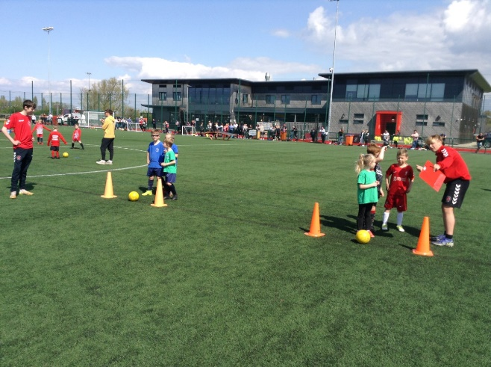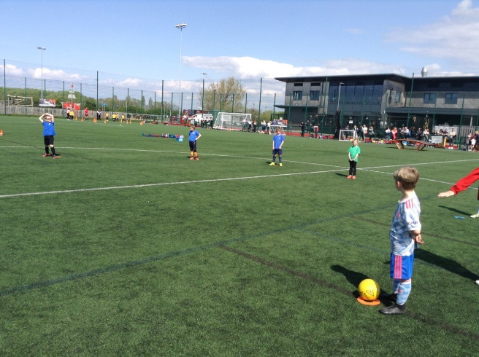
Please look at this link for further photographs: https://www.wyre-schools-ks1-foo.slf-studios.com/set/2bd6c82c-02e1-4cb8-9766-e9ee39c1201c

We are so sorry for IDL being down recently and any inconveniences caused, they have updated all passwords (which can be found in your child’s reading records) ready for you to use again. IDL has proved to dramatically increase reading and spelling ages so please remember to access it at least three times a week at home. If you have any login issues, please contact your child’s class teacher.

We were lucky enough to have a visit from Stuart Robinson MBE on Tuesday. The whole of school enjoyed a fitness challenge and an assembly. Stuart spoke about his wheelchair rugby career and what it was like to compete in the Paralympic Games for Great Britain. He showed us some of his training exercises, the children loved seeing some teachers try these! Thank you so much for all your generous sponsorship monies raised and sponsorship forms are due in school by next Tuesday.

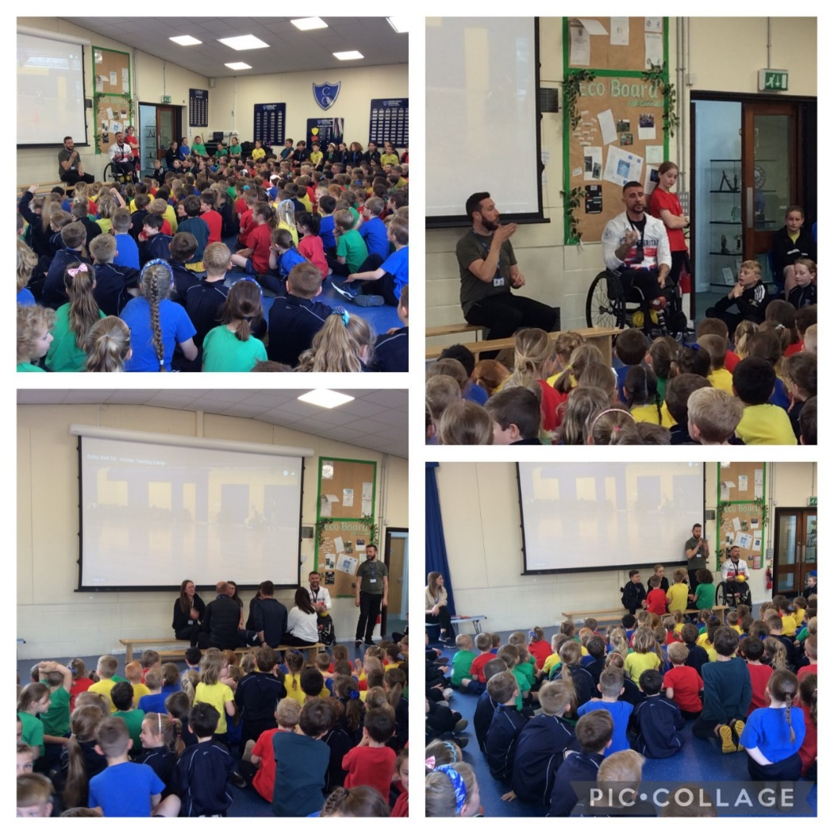

Thank you to everyone who supported the KS1 Open Afternoon learning about animals, we had fantastic turnout of parents and carers in the sunshine. The KS2 classes are to hold theirs next week.

The Dog trust was a huge success with the children finding out how to behave safely around dogs. We also have been incredibly fortunate to have cuddles with two lambs that joined us for a visit from Mrs Richardson’s farm. The pair were only a week old and very well behaved. The children found out lots of information about lambs.

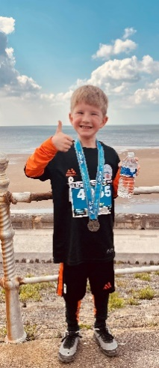
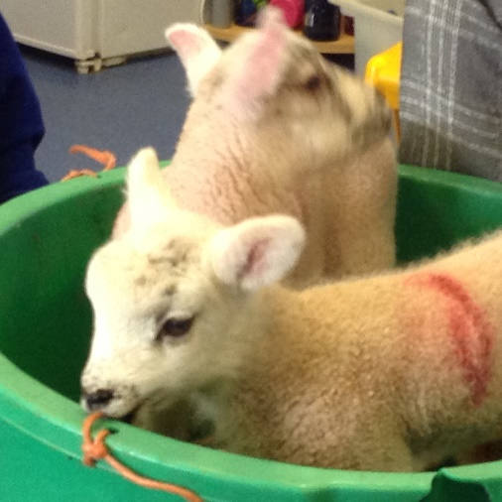
Congratulations to Jasper T for competing in this weekends Blackpool Festival of Running. After scoring a goal at a football match in the morning he insisted on remaining in his football kit to compete in a 2K race, in which he achieved his personal best after completing the race in 11 minutes 50 seconds. Well done Jasper!

Have a great bank holiday everyone!

