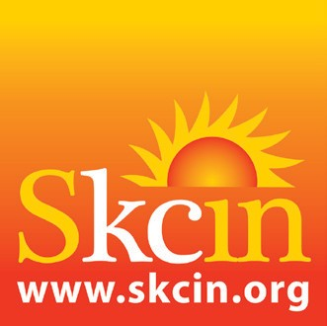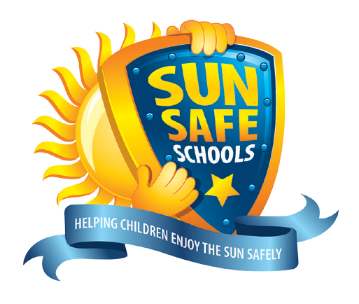

**SUN SAFETY POLICY**

**CARLETON GREEN COMMUNITY PRIMARY SCHOOL**

**DATE COMPLETED: 03 | 07 | 17**

**DATE REVIEWED:** 26 | 05 | 22

**DATE REVISIT:** 26 | 05 | 23

RATIONALE

Whilst we recognise that some sun is good for us, Sun Safety is an important health and safety issue for schools. Children spend almost half their childhood at school, with approximately 8 hours per week spent outdoors. During the warmer months of the year, children are exposed to UV radiation from the sun, the majority of which is when UV penetration is at its strongest (between 11am and 3pm). Without adequate protection, a child’s delicate skin can easily burn, causing accumulative and irreparable damage. This can significantly increase their risk of developing skin cancer in later life.

Skin cancer is the most common cancer in the UK with rates of the disease rising faster than any other cancer. Sun exposure in the first 15 years of life contributes significantly to a persons lifetime risk of skin cancer highlighting the importance of schools and parents working together, to increase knowledge, influence behaviour, ensure children are protected against UV and learn how to enjoy the sun safely.

|  |  |  |
| --- | --- | --- |
| **1. SUNSCREEN** | **IMPLEMENTING** | **PLANNING/ INVESTIGATING** |
| We actively remind parents to ensure their child brings a quality sunscreen to school / leaves their sunscreen at school for application as required | ✔ |  |
| We make available additional sunscreen for all outdoor activities, events and school trips where children may have forgotten, lost or run out of theirs | ✔ |  |
| We actively encourage pupils to apply sunscreen when UV levels reach 3 or above before extended periods outdoors such as lunch breaks, PE, or outdoor activities | ✔ |  |
| A practical approach toward the application of sunscreen will be necessary, with assistance provided only where necessary, unless instructed otherwise by the parent | ✔ |  |

|  |  |  |
| --- | --- | --- |
| **2. SUN HATS & CLOTHING** | **IMPLEMENTING** | **PLANNING/ INVESTIGATING** |
| We actively remind parents to ensure their child brings an appropriate sun hat to school / leaves their sun hat at school for use as required | ✔ |  |
| We make available additional/spare sun hats for all outdoor activities, events and school trips where children may have forgotten or lost theirs | ✔ |  |
| We make available uniform sun hats for parents to purchase | ✔ |  |
| We actively encourage pupils to wear their sun hat when UV levels reach 3 or above | ✔ |  |
| Baseball Caps are not recommended and will be phased out |  | ✔ |
| We use sun safe strategies to encourage pupils to cover up like ‘No hat, play in the shade’ | ✔ |  |
| We ensure pupils wear school and PE uniforms that keep shoulders covered, vests/strappy tops are strongly discouraged. Sunglasses are optional. | ✔ |  |

|  |  |  |
| --- | --- | --- |
| **3. SHADE** | **IMPLEMENTING** | **PLANNING/ INVESTIGATING** |
| We currently provide shaded areas outdoors where pupils congregate for outdoor play, lessons and activities. This can includes trees and/or purpose built or portable shade structures. | ✔ |  |
| We conduct shade assessments to consider future needs and are committed to investigating fundraising opportunities and improving shade solutions | ✔ |  |

|  |  |  |
| --- | --- | --- |
| **4. MONITORING UV** | **IMPLEMENTING** | **PLANNING/ INVESTIGATING** |
| We are committed to monitoring UV levels daily during warmer months to ensure appropriate sun safety measures are implemented when necessary | ✔ |  |
| A child from each class is selected to be the UV monitor and we display the days UV level to engage the children and reinforce the importance of sun safety on a daily basis | ✔ |  |

|  |  |  |
| --- | --- | --- |
| **5. STAFF AND ROLE MODELLING** | **IMPLEMENTING** | **PLANNING/ INVESTIGATING** |
| We ask staff to role model good sun safety behaviors such as applying sunscreen and wearing a sun hat when UV levels reach 3 or above | ✔ |  |
| We are committed to ensuring all staff are actively involved in the implementation of this policy and that they consider the UV forecast and sun protection/ control measures when planning outdoor activities or school trips | ✔ |  |

|  |  |  |
| --- | --- | --- |
| **6. SUN SAFETY EDUCATION** | **IMPLEMENTING** | **PLANNING/ INVESTIGATING** |
| We are committed to educating all pupils annually on sun safety using comprehensive, curriculum linked lesson plans, activities and resources provided by the Sun Safe Schools national accreditation scheme | ✔ |  |

|  |  |  |
| --- | --- | --- |
| **7. INFORMING THE SCHOOL COMMUNITY** | **IMPLEMENTING** | **PLANNING/ INVESTIGATING** |
| We communicate sun safety information through a range of channels e.g. our website, newsletters, text messages, social media, school assemblies and staff meetings | ✔ |  |

|  |  |  |
| --- | --- | --- |
| **8. REVIEW** | **IMPLEMENTING** | **PLANNING/ INVESTIGATING** |
| The school will regularly monitor and review the effectiveness of this policy and will update the policy on an annual basis in-line with renewing our Sun Safe Schools accreditation | ✔ |  |

**This policy has been agreed by the Governing Body and developed with guidance from the Sun Safe Schools national accreditation scheme Further information about the Sun Safe Schools scheme can be found at:** [**https://www.sunsafeschools.co.uk/education/**](https://www.sunsafeschools.co.uk/education/)

**Further information about skin cancer prevention and early detection can be found at:** [**www.skcin.org**](http://www.skcin.org)