Robin’s Homework
16th December 2022
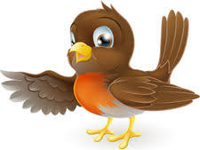
Tasks
Please try and complete what you can 😊. If you would like to email your work to me, my email is:
c.clarke@carletongreen.lancs.sch.uk
Maths – Please practise your addition and subtraction. I have attached some maths colouring sheets for you to practise, please choose the level you are comfortable with (separate attachment).
After half term, we will be moving on to money, can you recognise all of your coins?
Reading – Read your school reading book at home and ask a grown up to write in your reading record. Try and read a little bit every night.
Times tables -
Y2’s - Times tables rockstars https://ttrockstars.com/beta/ Please practise your 2s, 5s and 10s.
Y1’s – Login to Numbots
IDL- Access IDL 3 times a week.
Spelling test will be every Friday
Group 3 spelling rule:
- Short vowel sound, with one consonant – double the consonant and add ‘-ing’
e.g.: put= putting
Spellings | Group 1 | Group 2 | Group 3
 | Ship, shin, shop, shut, cash, mash, be, she, was, all | When, what, which, why, who, where, wheel, time, came, theme | Putting, shutting, clapping, flapping, swimming, shopping, getting, letting, old, don’t

Christmas Homework

Homework Task – Below, you have 15 tasks that you can choose to complete over Christmas. For each task you complete, you will get points. The pupil with the most points will get to choose 3 friends for extra play in January. Each task that is completed, has to be signed off by an adult in the space below the task.
But most importantly, relax, have fun and enjoy Christmas!

Watch a Christmas film  20 Points | Sing a Christmas song  20 Points | Have a hot chocolate  10 Points | Go to the park  25 Points
Write an acrostic poem for the word Christmas  30 Points | 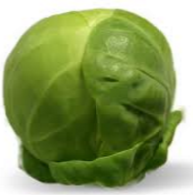  Eat a Brussel sprout  25 Points | 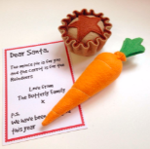  Leave presents out for Santa – Mince pie / Carrot  10 Points | Play with a friend  20 Points
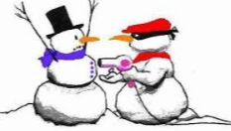  Tell a Christmas joke  10 Points | 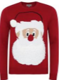  Go for a walk wearing a Christmas jumper or hat  40 Points | Wish someone a ‘Merry Christmas’  30 Points | Write a Christmas story including Santa and Rudolph  50 Points
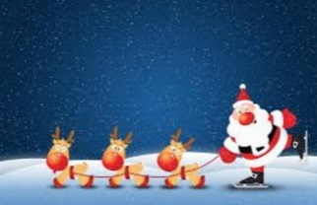  Draw a Christmas picture  30 Points | 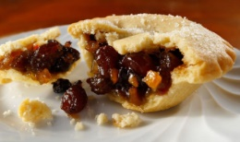  Eat a mince pie or some chocolate  15 Points | 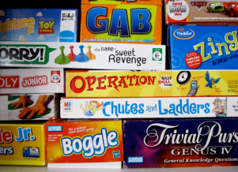  Play a board game  20 Points | Total Points Scored

