Year 1 Maths Homework 06.12.2019
Group the rabbits by drawing a ring around the number in each hutch.
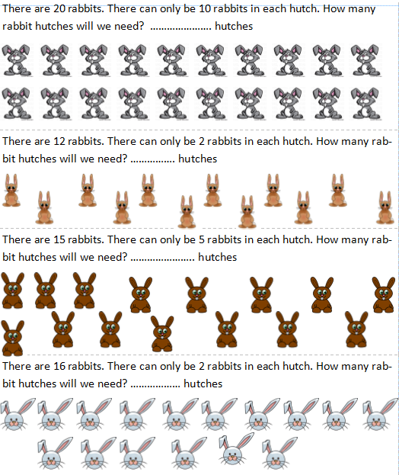

Year 2 Maths Homework 06.12.2019
Write the division number sentence to solve the problem. Answer the problem in a sentence.
