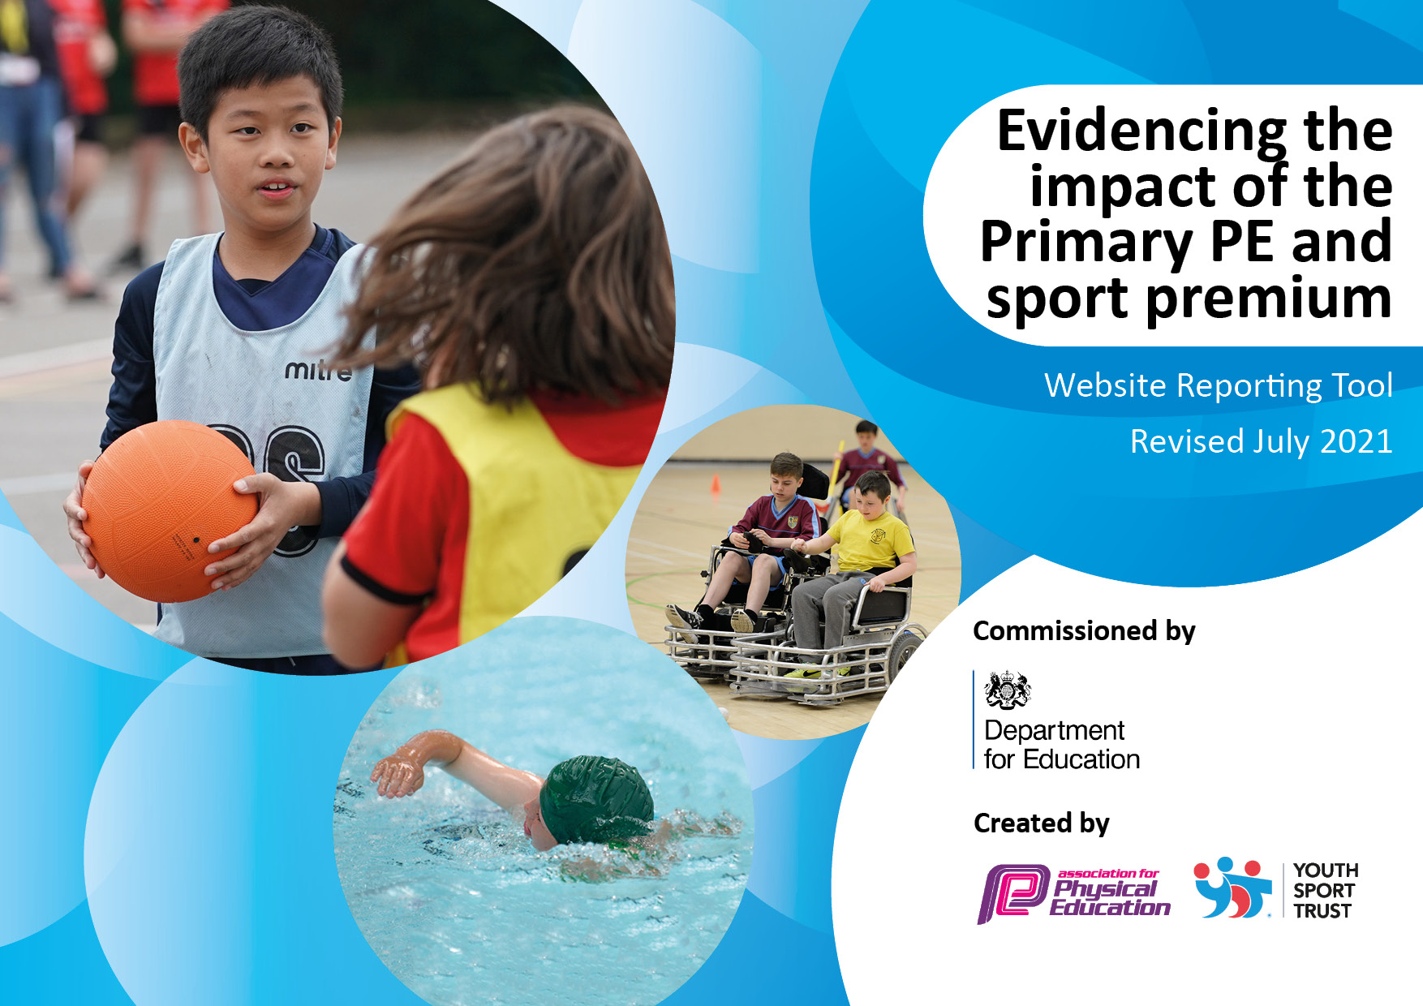
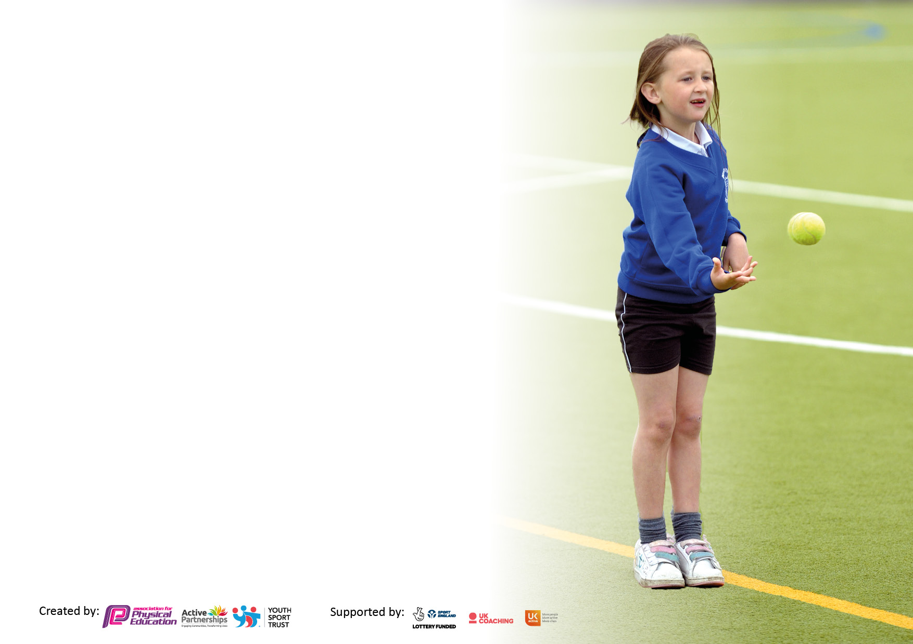

It is important that your grant is used effectively and based on school need. The Education Inspection Framework makes clear there will be a focus on ‘whether leaders and those responsible for governors all understand their respective roles and perform these in a way that enhances the effectiveness of the school’.

Under the Quality of Education Ofsted inspectors consider:
Intent - Curriculum design, coverage and appropriateness
Implementation - Curriculum delivery, Teaching (pedagogy) and Assessment
Impact - Attainment and progress

To assist schools with common transferable language this template has been developed to utilise the same three headings which should make your plans easily transferable between working documents.

Schools must use the funding to make additional and sustainable improvements to the quality of Physical Education, School Sport and Physical Activity (PESSPA) they offer. This means that you should use the Primary PE and sport premium to:

- Develop or add to the PESSPA activities that your school already offer
- Build capacity and capability within the school to ensure that improvements made now will benefit pupils joining the school in future years
- The Primary PE and sport premium should not be used to fund capital spend projects; the school’s budget should fund these.

Pleasevisitgov.ukfortherevisedDfEguidanceincludingthe5keyindicatorsacrosswhichschoolsshoulddemonstrate animprovement.Thisdocumentwillhelpyoutoreviewyourprovisionandtoreportyourspend.DfEencouragesschools to use this template as an effective way of meeting the reporting requirements of the Primary PE and sport premium.

We recommend you start by reflecting on the impact of current provision and reviewing the previous spend.

Schools are required to publish details of how they spend this funding, including any under-spend from 2019/2020, as well as on the impact it has on pupils’ PE and sport participation and attainment. All funding must be spent by 31st July 2022.

We recommend regularly updating the table and publishing it on your website throughout the year. This evidences your ongoing self-evaluation of how you are using the funding to secure maximum, sustainable impact. Final copy must be posted on your website by the end of the academic year and no later than the 31st July 2021. To see an example of how to complete the table please click HERE.
Created by: Supported by:

Details with regard to funding
Please complete the table below.

Total amount carried over from 2019/20 | £0
Total amount allocated for 2020/21 | £0
How much (if any) do you intend to carry over from this total fund into 2021/22? | £0
Total amount allocated for 2021/22 | £18,500
Total amount of funding for 2021/22. To be spent and reported on by 31st July 2022. | £ 18,500
Swimming Data
Please report on your Swimming Data below.

Meeting national curriculum requirements for swimming and water safety.

N.B. Complete this section to your best ability. For example you might have practised safe self-rescue techniques on dry land which you can then transfer to the pool when school swimming restarts.
Due to exceptional circumstances priority should be given to ensuring that pupils can perform safe self rescue even if they do not fully meet the first two requirements of the NC programme of study
What percentage of your current Year 6 cohort swim competently, confidently and proficiently over a distance of at least 25 metres?  N.B. Even though your pupils may swim in another year please report on their attainment on leaving primary school at the end of the summer term 2021.  Please see note above | %
What percentage of your current Year 6 cohort use a range of strokes effectively [for example, front crawl, backstroke and breaststroke]?  Please see note above | %
What percentage of your current Year 6 cohort perform safe self-rescue in different water-based situations? | %
Schools can choose to use the Primary PE and sport premium to provide additional provision for swimming but this must be for activity over and above the national curriculum requirements. Have you used it in this way? | Yes/No

Action Plan and Budget Tracking
Capture your intended annual spend against the 5 key indicators. Clarify the success criteria and evidence of impact that you intend to measure to evaluate for pupils today and for the future.

Academic Year: 2022/23 | Total fund allocated: | Date Updated:
Key indicator 1: The engagement of all pupils in regular physical activity – Chief Medical Officers guidelines recommend that primary school pupils undertake at least 30 minutes of physical activity a day in school |  |  |  | Percentage of total allocation:
 |  |  |  | %
Intent | Implementation |  | Impact
Your school focus should be clear what you want the pupils to know and be able to do and about  what they need to learn and to  consolidate through practice: | Make sure your actions to achieve are linked to your intentions: | Funding allocated: | Evidence of impact: what do pupils now know and what can they now do? What has changed?: | Sustainability and suggested next steps:
To ensure all children are active and are provided with opportunity to develop key skills and access a variety of different activities and sports. To create times for children to practise during breaks and lunch times | Welfare team use playtime and sport equipment to provide a variety of opportunities to be active and build on skills learned in PE lessons through games and sports.  A large selection of playground equipment is available on each playground. It is stored in outdoor storage and made available at every break. Selection includes a variety of bats, different size balls, skipping ropes, target games, nets and hoops, markers and cones to set up obstacle races. | £140.95  £233.33 | Staff voice – Saves time going to the PE cupboard and the kids are taking more responsibility for the kit.  Pupil voice – It’s so much easier with the storage, we can get the things out ourselves and don’t need to ask all the time.  Observation – Equipment is well organised and being cared for. | Continue to audit supplies and top up at regular intervals.
To ensure that all children – with an emphasis on those less likely to want to participate in competitive sports can join in and offered opportunities. | A selection of current year 4 and 5 students to be trained as playground leaders in Spring 2 of 2023 to provide a variety of games with both KS1 and KS2 students.  Students should become skilled in planning and implementing a variety of activities.  Activities should include competitive team games and personal best activities.  Inclusion events entered across KS1 and KS2 throughout year to encourage those less likely to attend sporting events or represent the school in other competitions.  KS1 – inclusion multi skills  Year 3/4 – inclusion multi skills  Year 5/6 – Inclusion glow dodgeball | £250  £180 | Spring 2 – delivered by WFSSP  Two activity/games on each playground each lunchtime. Children engaged, moving around more and less arguments/social issues as we return to class after lunch.  Pupil voice – ‘It’s been fun getting to know the little kids and learning new games with them all, keeps me running around too, I look forward to when I’m on duty’
Key indicator 2: The profile of PESSPA being raised across the school as a tool for whole school improvement |  |  |  | Percentage of total allocation:
 |  |  |  | %
Intent | Implementation |  | Impact
Your school focus should be clear what you want the pupils to know and be able to do and about  what they need to learn and to  consolidate through practice: | Make sure your actions to achieve are linked to your intentions: | Funding allocated: | Evidence of impact: what do pupils now know and what can they now do? What has changed?: | Sustainability and suggested next steps:
Celebrate the sporting achievements of our students.  Advertise and celebrate the success of our sports provision provided at our school. | PE board in hall has images of sporting competitions, certificates earned. Children invited to send in pictures of any outside school sporting achievements.  Sports newsletter (written by our Sports Captain and published in our school newsletter)  Children celebrated in weekly class, school or phase assemblies.  Board in reception area shows the clubs available to our students. Details and images included in the school newsletter and shared on school website. | £0  £0

Key indicator 3: Increased confidence, knowledge and skills of all staff in teaching PE and sport |  |  |  | Percentage of total allocation:
 |  |  |  | %
Intent | Implementation |  | Impact
Your school focus should be clear | Make sure your actions to | Funding | Evidence of impact: what do | Sustainability and suggested
what you want the pupils to know | achieve are linked to your | allocated: | pupils now know and what | next steps:
and be able to do and about | intentions: |  | can they now do? What has
what they need to learn and to |  |  | changed?:
consolidate through practice:
Increase of staff confidence in assessing skills and progress across PE lessons.  Staff enabled and to deliver a wide curriculum across a two-year cycle covering all skills that provides regular assessment opportunities to stretch able students as well as support the less able. | PE Passport used across school.  Staff training of PE passport to ensure all staff know how to use it. Planning scheme on the app used in lessons. Assessment tool used within lessons to enable instant feedback and support to students. | £384  (PE Passport) | Greater and wider use of PE passport has…  Trained staff to use PE Passport for extra curricular and competitions in order to provide us with helpful data regarding students activity levels and attendance. This years statistics have shown us that boys in our school benefit more from PE based extra curricular clubs and after school. | Continue to invest in PE Passport for planning and assessment purposes.  Continue to make sure that all clubs are registered on PE Passport and attendance is monitored.  - Gain pupil and parent voice about club choice, targeting girls and PP students to attend.  - Look at timetabling of different clubs to engage more children in before school activities.  - Encourage more girls to take part (girls football set up)
To continue to develop and improve the teaching of fundamental movement skills across KS1. Focussing on teacher subject knowledge and understanding of baseline and assessment.  This will ensure that children’s needs and ability is identified quickly, enabling their key skills to progress effectively throughout the year. | FTFC support in lessons provided to all KS1 classes in Autumn term to help provide opportunities to assess and baseline the class, leading to the teacher’s ability to choose the right units for their children.  FTFC in to support UKS2 classes in Spring 2023 | £1440  £1440 | Autumn – feedback from Emma, Emily and Catherine  Sara Bagwell (Year 5/6)  I had Fleetwood Town for cricket. They were really good from a teacher perspective because it helped to develop my skills and ability to teach others in relation to lesson progression and examples of skills. The children were also well organised and extended at their varying levels. Key children were chosen to model examples - sometimes these were the GDS children but sometimes they were the most improved children. All children were really engaged in sessions and improved on their starting points. One child said after a batting focus 'I didn't think I was good at cricket but I am'. He had developed his skills so much through the lesson that he hit the ball right across the playground after it had been bowled to him, using the correct grip.
Develop staff understanding of effective dance teaching that ensures progress for all pupils. | Brittany from Dance Etc hired to teach two classes a term. Classes chosen based on staff audit completed in 21021/22 highlighting dance as an area for improvement with confidence and subject knowledge.  Class teacher works alongside Brittany to share knowledge and expertise. | £1440 (up until end of Spring 2023) | Staff voice –  J.Shepherd – the children are highly engaged in the lessons. I feel like I’ve learned a lot from working with Brittany. She’s helped me see how to build a unit – connect it to our topic and assess the pupils. Use’s passport alongside me to help encourage students.  Pupil voice – Kestrels - Excited to do dance every week now.  Observation – Children engaged, Brittany is very encouraging and supportive with the class.
Develop staff understanding of effective games skills that ensures progress of all pupils. | Tennis coach in lesson provision across UKS2. Class teacher to work alongside them to share knowledge and expertise.  Use of staff audit to ensure that the provision provided matches the areas they most want to improve.  Cricket coach in lesson provision across KS2. Class teacher to work alongside them to share knowledge and expertise. | £0  £0 | Autumn 2 – Jeanette and Jen  The lessons were well structured and met the needs of all the children from those who had very little tennis experience to those who play tennis regularly outside of school. The children were given opportunities to practise holding a racket correctly, hitting the ball forehand and backhand and how to get the ball over the net. The children responded very well to all the activities and benefitted from the expertise of the leaders. They also developed in their understanding of the rules of tennis.  Cricket provision - Jeremy was clearly very knowledgeable and structured his coaching in a logical fashion based on his experience coaching the sport. He explained and demonstrated key coaching points really well and was able to help all children to experience success and make progress in the sport.
Further develop the staff understanding of effective fundamental movement skills across the foundation stages. | Little Chicks (nursery) and Ducklings (Reception) to receive provision from FTFC. Allows teaching staff to work alongside them sharing knowledge and expertise.  Allows teaching staff to focus on assessment and progress from beginning of year to end. Ensuring a smooth handover to next phase, particularly year 1, ready for the fundamental skills baseline. | £960  (Ducklings)  £252  (Little Chicks) | Spring and Summer
To increase the confidence of staff across different elements of the PE curriculum and sport across our school. | Regular attendance of professional development courses across the teaching staff.  Fundamental Movement Skills  C.Clarke attended in September 2022 – to improve her confidence and ability to provide effective FMS lessons.  WFSSP PE Conference October 2022  S.McGrath and J Shepherd attended.  A variety of workshops delivered, providing key updates within PE and sport. Provided data update, Ofsted updates, activity within the school day, school games and inter school competition  EYFS Trails and Trusts  KS2 Teaching High Quality Dance and Gymnastics | £99  £250  £189  £189 | Feedback from staff  C.Clarke –Emphasis on using STEP to challenge and enable all children to meet skills.  Also learnt how to use the skills in a game.  Children are now more engaged in purposeful and relevant movement, helping them to achieve at the assessment point at the end of year 2.  J.Shepherd – informative day discussing different elements of PE and sport in school.  - changed PE schedule to two days per week, maximising our 60 mins and increasing weekly activity levels of students.  - focus on active learning and emphasising the 60 minutes taken back and highlighted to staff.  - useful PE Passport training reiterated to staff to streamline our reporting  (June 2023)  JS attended – focus on progression | Continue to audit staff twice yearly (Autumn and Summer) to see where they would most like provision and development and to see confidence of sport and PE across the school.
Key indicator 4: Broader experience of a range of sports and activities offered to all pupils |  |  |  | Percentage of total allocation:
Intent | Implementation |  | Impact
Your school focus should be clear | Make sure your actions to | Funding | Evidence of impact: what do | Sustainability and suggested
what you want the pupils to know | achieve are linked to your | allocated: | pupils now know and what | next steps:
and be able to do and about | intentions: |  | can they now do? What has
what they need to learn and to |  |  | changed?:
consolidate through practice:
To provide a wide variety of before and after school clubs that offer different sports and opportunities to be active. | After school clubs offered throughout the year.  Three (four during summer) after school club options provided each term from FTFC  (KS1 and KS2 options in all terms)  Multi skills KS1, Multi skills KS2, Football KS1, Football KS2, athletics, netball, tennis  Rugby – Autumn 1, years 3/4  Cricket – Spring 2, years 5/6  Staff led sport and activity clubs include  -running (throughout year)  - football (throughout year)  - dance (throughout year)  - dodgeball (Autumn 1 and 2)  - rounders (Summer)  Other clubs led in school through year  (private cost to students)  - Judo (Autumn)  - Fencing (Autumn)  - Taekwondo (throughout year  Golf club aimed at increasing amount of girls in sport. Course and six week club ran by JW. | £3927  £250  £250  £0  £0  £70 cost to school | After school clubs are well attended in all phases.  Summer 1 saw 128 Pupils attending a sporting ASC compared to Autumn 1 of 82.  Rugby – 10 children (Year 3/4) attended for five weeks.  Observation – highly engaged, very active.  Cricket – 10 children (Year 5/6) attended for five weeks.  Running – 16 children attended (KS2) in Aut 1.  Student voice  - great start to the day, helping me run for longer and quicker.  - Love running club on a Wednesday, enjoy running round the field and playing games with everyone.  Golf – 18 children in attendance (no golf offered previously) | Book rugby again  Continue to run running club through year.  Keep football running all year if possible as they are highly attended and very popular across all phases. Keep ¾ and 5/6 on the same day with two coaches and JT.  Send out survey to parents and children to see what clubs they would most like to see next year.
To provide additional swimming for children in years 4 – 6 for those who cannot swim 25m with a variety of strokes or perform effective water safety.  This is above and beyond the national curriculum provision already provided. | Focus on increasing the amount of children able to meet national curriculum standards and our pupil premium students. | £3150 | Additional lessons given to children who passed with ease. Advanced lessons focussing on breathing, technique and stamina.  Current year 6 has a 75% pass rate  Current year 5 has a 60% pass rate  Current year 4 has a 63% pass rate | Continue to use Big Fish Little Fish and use premium for extra lessons if required – available.
To provide an exposure to a variety of different sports in our curriculum. | Purchased PE equipment to ensure quality lessons in a variety of sports.  Tennis rackets and nets, badminton, new vests, new netballs, athletic equipment and footballs.  Netball CPD attended by JS and CC | £384.48  £291.92  £50 (£25 x 2) | Aim of the netball course is to start having a netball club and team within school. | Continue with this journey to a netball team.
To provide an exposure to different forms of activity and movement to all pupils | Mindfulness and yoga experience day for the whole of school – provided by yogi group. | £0 | Children feedback – really enjoyed it, gave some great ideas on how to relax and practise mindfulness.

Key indicator 5: Increased participation in competitive sport |  |  |  | Percentage of total allocation:
 |  |  |  | %
Intent | Implementation |  | Impact
Your school focus should be clear | Make sure your actions to | Funding | Evidence of impact: what do | Sustainability and suggested
what you want the pupils to know | achieve are linked to your | allocated: | pupils now know and what | next steps:
and be able to do and about | intentions: |  | can they now do? What has
what they need to learn and to |  |  | changed?:
consolidate through practice:
Develop opportunities for competition within school. | Welfare staff and year 6 prefects to provide games on both the KS1 and KS2 playgrounds during lunch.  Autumn – speed bounce  Spring – timed sprint  Summer – foam howler |  | Observation  - Children engaged in a variety of different activities across the playground.  Staff voice  - Behaviour is much improved when there are more activities and equipment on the playground  - Year 3/4 have been competing at breaktimes in classes to compete in games.  Observation  - A lot of students asking if we can do it every day, offering ideas for future competitions.  - A lot of students completing it every week and interested to see their improvement  - Students cheering each other on. | Continue to use student and staff voice to make sure that there is plenty of equipment available and share ideas across staff to vary games and activities through the week and year.  Moving forward look at holding house competitions once per term, could move to two sports days per year.
Ensure that we compete in competitions against other schools. | Teams entered in a wide variety of competitions through the WFSSP sports offer.  KS1 – multi skills, football skillz  Year 3/4 – multi skills, football, striking and fielding, quad kids athletics, girls football  Year 5/6 – athletics, girls football, netball, glow dodgeball, quadkids athletics  Sports kit purchased for students to wear across all sports – showing united team in matching kit. | £900  £242.88 | Student voice Multi skills year 3/4  - Brilliant fun! Lots of fun games and running around. I’m tired and hot now!  - So much fun! Can we do some of the stuff at break time?  Observation – children love matching each other at school events. Worn across all phases at a variety of competitions.

Signed off by
Head Teacher:
Date:
Subject Leader:
Date:
Governor:
Date:

