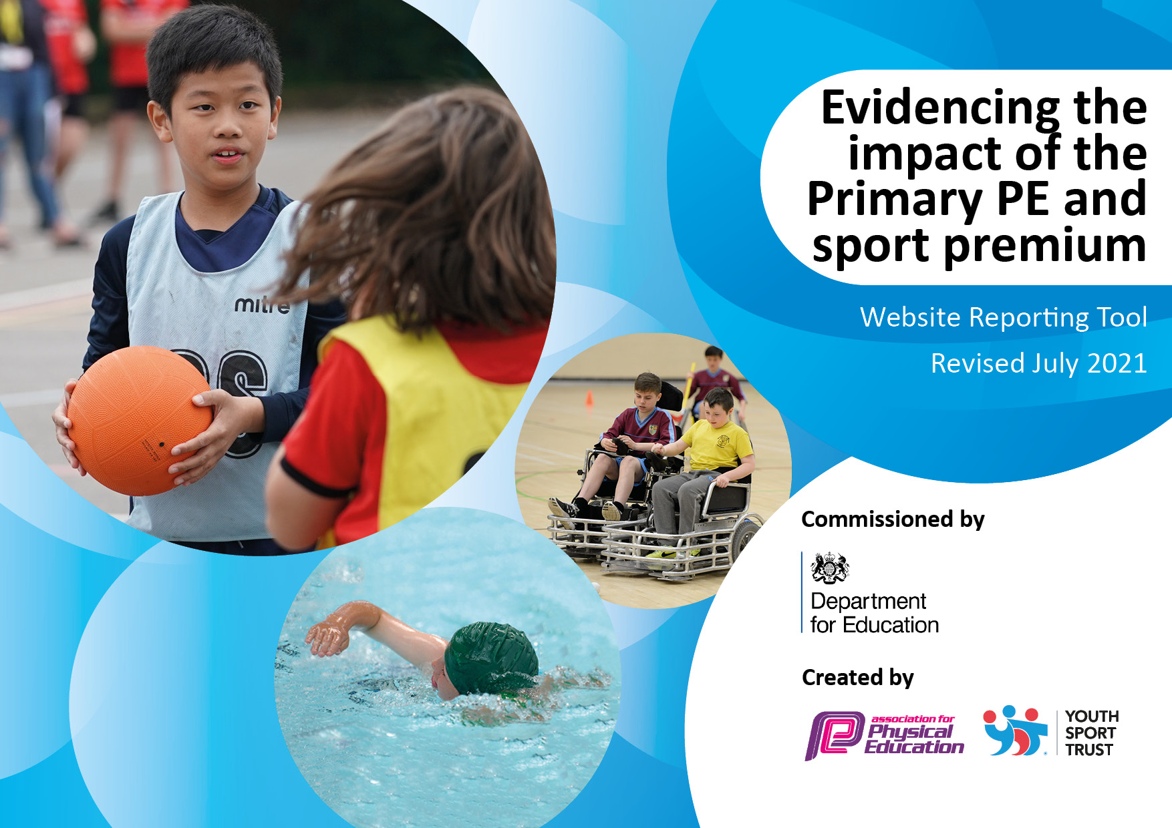
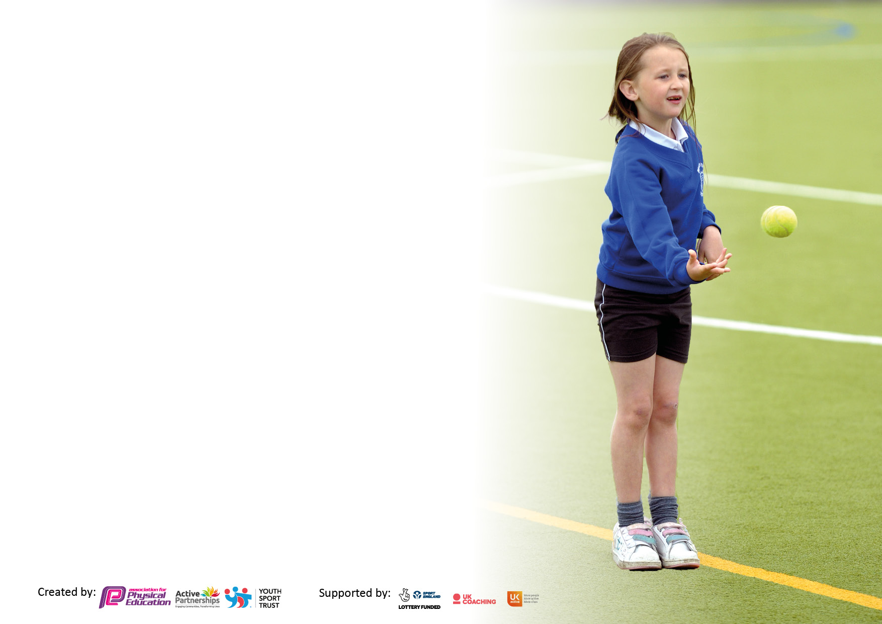

It is important that your grant is used effectively and based on school need. The Education Inspection Framework makes clear there will be a focus on ‘whether leaders and those responsible for governors all understand their respective roles and perform these in a way that enhances the effectiveness of the school’.

Under the Quality of Education Ofsted inspectors consider:
Intent - Curriculum design, coverage and appropriateness
Implementation - Curriculum delivery, Teaching (pedagogy) and Assessment
Impact - Attainment and progress

To assist schools with common transferable language this template has been developed to utilise the same three headings which should make your plans easily transferable between working documents.

Schools must use the funding to make additional and sustainable improvements to the quality of Physical Education, School Sport and Physical Activity (PESSPA) they offer. This means that you should use the Primary PE and sport premium to:

- Develop or add to the PESSPA activities that your school already offer
- Build capacity and capability within the school to ensure that improvements made now will benefit pupils joining the school in future years
- The Primary PE and sport premium should not be used to fund capital spend projects; the school’s budget should fund these.

Pleasevisitgov.ukfortherevisedDfEguidanceincludingthe5keyindicatorsacrosswhichschoolsshoulddemonstrate animprovement.Thisdocumentwillhelpyoutoreviewyourprovisionandtoreportyourspend.DfEencouragesschools to use this template as an effective way of meeting the reporting requirements of the Primary PE and sport premium.

We recommend you start by reflecting on the impact of current provision and reviewing the previous spend.

Schools are required to publish details of how they spend this funding, including any under-spend from 2019/2020, as well as on the impact it has on pupils’ PE and sport participation and attainment. All funding must be spent by 31st July 2022.

We recommend regularly updating the table and publishing it on your website throughout the year. This evidences your ongoing self-evaluation of how you are using the funding to secure maximum, sustainable impact. Final copy must be posted on your website by the end of the academic year and no later than the 31st July 2021. To see an example of how to complete the table please click HERE.
Created by: Supported by:

Details with regard to funding
Please complete the table below.

Total amount carried over from 2019/20 | £11670.10
Total amount allocated for 2020/21 | £29819.00
How much (if any) do you intend to carry over from this total fund into 2021/22? | £12366.67
Total amount allocated for 2021/22 | £18563.00
Total amount of funding for 2021/22. To be spent and reported on by 31st July 2022. | £30867
Swimming Data
Please report on your Swimming Data below.

Meeting national curriculum requirements for swimming and water safety.

N.B. Complete this section to your best ability. For example you might have practised safe self-rescue techniques on dry land which you can then transfer to the pool when school swimming restarts.
Due to exceptional circumstances priority should be given to ensuring that pupils can perform safe self rescue even if they do not fully meet the first two requirements of the NC programme of study
What percentage of your current Year 6 cohort swim competently, confidently and proficiently over a distance of at least 25 metres?  N.B. Even though your pupils may swim in another year please report on their attainment on leaving primary school at the end of the summer term 2022.  Please see note above | 81%
What percentage of your current Year 6 cohort use a range of strokes effectively [for example, front crawl, backstroke and breaststroke]?  Please see note above | 74%
What percentage of your current Year 6 cohort perform safe self-rescue in different water-based situations? | 94%
Schools can choose to use the Primary PE and sport premium to provide additional provision for swimming but this must be for activity over and above the national curriculum requirements. Have you used it in this way? | Yes/No

Action Plan and Budget Tracking
Capture your intended annual spend against the 5 key indicators. Clarify the success criteria and evidence of impact that you intend to measure to evaluate for pupils today and for the future.

Academic Year: 2021/22 | Total fund allocated: | Date Updated:
Key indicator 1: The engagement of all pupils in regular physical activity – Chief Medical Officers guidelines recommend that primary school pupils undertake at least 30 minutes of physical activity a day in school |  |  |  | Percentage of total allocation:
Intent | Implementation |  | Impact
Your school focus should be clear what you want the pupils to know and be able to do and about  what they need to learn and to  consolidate through practice: | Make sure your actions to achieve are linked to your intentions: | Funding allocated: | Evidence of impact: what do pupils now know and what can they now do? What has changed?: | Sustainability and suggested next steps:
Children to engage further with curriculum delivery. Develop in school competitions and deliver intervention for groups of children where appropriate. | Fleetwood Town curriculum coaching support and lunchtime/after school clubs. | Included in FTFC funding | Children attending after school clubs.  A variety of sports offered and experiences given to children across the school. | Continue relationship with FTFC next year to keep offering a variety of experiences through after school clubs and lunchtime offers.
To provide playground equipment that children can use to increase their physical activity at break and lunch. | Equipment on KS2 yard  Equipment on KS1 yard | £13,963 | Increase activity during break and lunch times. Used within continuous provision in EYFS. | Keep maintaining equipment. Use sports council members to assess the most popular equipment during break times.
To provide playground equipment that children can use to increase their physical activity at break and lunch. | Range of equipment ordered suitable for each phase. | £1393.06 | From observation – increase in choice of equipment and games available to children shows more children being active and involved and moving during break times. | Continue to monitor stock of equipment and encourage children and adults to take care storing it and using it.
To provide PE equipment to meet the needs of the national curriculum. | Equipment for PE | £1473.49 | From observation and staff voice, lessons are well resourced and equipment is of a good standard | Continue to monitor stock of equipment and encourage children and adults to take care storing it and using it.
Key indicator 2: The profile of PESSPA being raised across the school as a tool for whole school improvement |  |  |  | Percentage of total allocation:
Intent | Implementation |  | Impact
Your school focus should be clear what you want the pupils to know and be able to do and about  what they need to learn and to  consolidate through practice: | Make sure your actions to achieve are linked to your intentions: | Funding allocated: | Evidence of impact: what do pupils now know and what can they now do? What has changed?: | Sustainability and suggested next steps:
PE & SCHOOL SPORT REVIEW & VISION | Meet with SGO to discuss where are at with PE in school and how this can be developed. | £50 | Changes within school to allow for more inter school and intra school competition and focus on ways to implement and strengthen the 60 mins of activity per day. | Implement changes throughout next academic year involving personal bests and competitions across school.
Lancashire PE Passport App membership | Further develop productive use of APP – Feedback this to staff in school. | £1150 | Easy access to plans on ipads in lessons. Assessment easy to complete and during lesson time. | Regular subject leader check on app usage and staff confidence with using it.
Blue Moose Year 6 dance | One day of dance input from Blue Moose | £300 | Whole of year 6 cohort involved in a quality group dance experience | Enjoyed by all children, book in for next year.
Improve the knowledge for PE subject leader | Membership to AFPE | £115 | Access to network and regular webinars to improve PE within school. | Continue membership

Key indicator 3: Increased confidence, knowledge and skills of all staff in teaching PE and sport |  |  |  | Percentage of total allocation:
 |  |  |  | 4%
Intent | Implementation |  | Impact
Your school focus should be clear | Make sure your actions to | Funding | Evidence of impact: what do | Sustainability and suggested
what you want the pupils to know | achieve are linked to your | allocated: | pupils now know and what | next steps:
and be able to do and about | intentions: |  | can they now do? What has
what they need to learn and to |  |  | changed?:
consolidate through practice:
CPD delivered across school to specific teachers and during staff meeting time | Gym and dance KS1  Gym and dance KS2  Trails and Challenges EYFS  Blue Moose Dance Company twilight  PE Passport training  EYFS training | £560 | Staff able to deliver and teach well structured lessons | Staff who attended courses to feedback to others, sharing best practice.
Key indicator 4: Broader experience of a range of sports and activities offered to all pupils |  |  |  | Percentage of total allocation:
 |  |  |  | 20%
Intent | Implementation |  | Impact
Your school focus should be clear | Make sure your actions to | Funding | Evidence of impact: what do | Sustainability and suggested
what you want the pupils to know | achieve are linked to your | allocated: | pupils now know and what | next steps:
and be able to do and about | intentions: |  | can they now do? What has
what they need to learn and to |  |  | changed?:
consolidate through practice:
To provide children with experiences not currently offered in our school and allow staff time to receive CPD of those sports | Fylde Rugby Reading and Rugby sessions | £500 | Year 5/6 children (90 children) received 6 weeks’ worth of rugby lessons. | Consider running it again next school year or bringing Fylde Rugby in for Extra Curricular clubs.
To provide children with experiences not currently offered in our school and allow staff time to receive CPD of those sports | FTFC sessions | £7385 | Children attending after school clubs.  A variety of sports offered and experiences given to children across the school. | Continue relationship with FTFC next year to keep offering a variety of experiences through after school clubs and lunchtime offers.
To provide children with experiences not currently offered in our school and allow staff time to receive CPD of those sports | Healthy Heads  Quidditch  Dance coach  Mindfulness Day  Mental Health and yoga day | £620 | Children enjoyed a variety of different experiences that aren’t offered on a daily basis at school. | Yoga and mindfulness day booked in for next year.

Key indicator 5: Increased participation in competitive sport |  |  |  | Percentage of total allocation:
 |  |  |  | 16%
Intent | Implementation |  | Impact
Your school focus should be clear | Make sure your actions to | Funding | Evidence of impact: what do | Sustainability and suggested
what you want the pupils to know | achieve are linked to your | allocated: | pupils now know and what | next steps:
and be able to do and about | intentions: |  | can they now do? What has
what they need to learn and to |  |  | changed?:
consolidate through practice:
School to provide children across all year groups with opportunities to represent their school house and school as a whole at competitions in a range of disciplines | Wyre and Fylde SSP offer | £2750 | High profile of sport and competition across school and key stages. Children proud to represent school. | Continue to sign the school up for WFSSP and give sporting and competition opportunities to more children.
Team sportswear for all children to wear at inter school competitions. | Sportswear and team kits ordered in a variety of sizes | £607.45 | Used across different competitions and sports through the year. | Consider a wider variety of sizes and styles, budget dependent.

Signed off by
Head Teacher: | S McGrath
Date: | 14.07.22
Subject Leader: | J Shepherd
Date: | 13.07.22

