**Friday 16th September 2022**

Homework

Spellings:

Please practise the spellings in the reading journals. The test will be on Friday.



Writing / Topic:

This week we wrote a dairy entry based on the book Stig of the Dump.

This week’s homework is to pick a character from any other book and write a diary entry as that character.



Maths:

There is some maths work on Education City



Reading:  
  
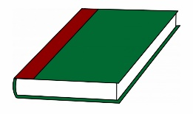

Continue to read your reading books at home.

More books can be accessed through the website Oxford Owl.

Please do not hesitate to come and see me if you would like to discuss anything about this week’s homework.

Mrs Shepherd   
j.shepherd@carletongreen.lancs.sch.uk