**Friday 23rd September 2022**

Homework

Spellings:

Please practise the spellings in the reading journals. The test will be on Friday.

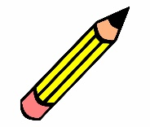

Writing / Topic:

This week we have started thinking about sculpture in art. Please spend some time at making a sculpture. It can be made from anything and be of anything. Pictures can be emailed to me or sent in. (you could use lego, stones at the beach, things from the garden)



Maths:

There is some maths work on Education City

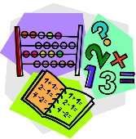

Reading:  
  
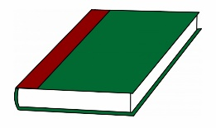

Continue to read your reading books at home.

More books can be accessed through the website Oxford Owl.

Please do not hesitate to come and see me if you would like to discuss anything about this week’s homework.

Mrs Shepherd   
j.shepherd@carletongreen.lancs.sch.uk