**Friday 30th September 2022**

Homework

Spellings:

Please practise the spellings in the reading journals. This week I have changed the format of the spellings to reflect each learner’s needs. I hope you find they find the new colour layout helpful. Any problems or questions please let me know.

The tests will remain on Fridays.



Writing / Topic:

This week I have put all homework on Education City. Any problems logging on then let me know.



Maths:

There is some maths work on Education City



Reading:  
  
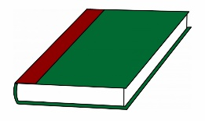

Continue to read your reading books at home.

More books can be accessed through the website Oxford Owl.

Please do not hesitate to come and see me if you would like to discuss anything about this week’s homework.

Mrs Shepherd   
j.shepherd@carletongreen.lancs.sch.uk