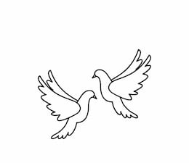
Friday 10th September 2021 Due: Wednesday 15th September
Homework
This week we have started our new Ancient Egypt topic. We have been using maps to find and locate Egypt and we have been putting historical events on a timeline. Can you remember what BC means? We have been learning about place value in Maths including counting in multiples of twenty-five and fifty. I hope you all have a great weekend.
Handwriting:
Practise writing your spelling words in neat, cursive handwriting.
Writing / Topic:
This week we have learning about coordinating conjunctions.
Please write five sentences using conjunctions. Can you remember FANBOYS to help you.

Maths:
Complete the maths activity on Education City. This will link to all of the work we have done in maths this week.

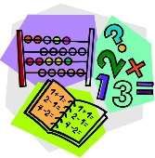

Reading:
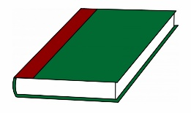
You now have your new reading journal. Please read at home every night and talk about the story.

Don’t forget…
Please bring some fairy cakes to school on Friday 17th. We are hosting Fairy Cake Friday. Thank you.

Please do not hesitate to come and see me if you would like to discuss anything about this week’s homework.
Miss Clarkson
e.clarkson@carletongreen.lancs.sch.uk

