Homework – Friday 23rd September

Welcome to Parrots class, we can’t wait to work with you this year. Each week, we will upload this document with your homework on that you will complete and then email back to either myself or Miss Lee. We really encourage practical learning and engaging activities; not everything has to be wrote down on pen and paper. You could chalk your spellings, create word searches or even draw pictures linked to your spellings. Maths might be on Education City or it might be for you to practically create a shop!
Any questions please do email and let us know if you have any problems.

Maths- Education City – Please find log in details on the home learning page.
Reading – Please read your reading book every day and discuss the setting of the story.
Topic – Can you go on a material hunt around your house and discuss with your grown up what properties the materials have, for example, the table might be made out of wood and feel hard.

TTRS/Numbots (Please access these as and when you can)
Year 2: please practice your 2’s, 5’s, 10’s times tables on TTRS
Year 1: Numbots – please see username and password information in reading journals and do this every night (it will help with place value/number work.) Work your way through the levels and keep at it.
I will check who is accessing this weekly.
IDL: Logins will be in reading journals this week so that you can access 3 times a week at home.

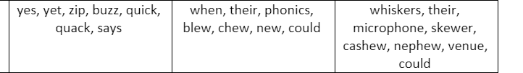
Spellings
Group 1 Group 2 Group 3

Reminders
Wear Green Day – 14th October

