Homework – Friday 13th January

In Parrots, we really encourage practical learning and engaging activities; not everything has to be wrote down on pen and paper. You could chalk your spellings, create word searches or even draw pictures linked to your spellings. Maths might be on Education City or it might be practical.
Any questions please do email and let us know if you have any problems.
This week please email homework to Miss Lee

Maths- Education City – Please find log in details on the home learning page. Access the level appropriate for you.
Reading- Please write a blurb for your reading book. A blurb is at the back of the book and gives a short explanation of what the book is about.
Topic – Please send in a picture of you at the seaside. If you would prefer to email; email to Mrs Davis.

TTRS/Numbots (Please access these as and when you can)
Year 2: please practice your 2’s, 5’s, 10’s, 3’s times tables on TTRS
Year 1: Numbots – please see username and password information in reading journals and do this every night (it will help with place value/number work.) Work your way through the levels and keep at it.
IDL: Logins will be in reading journals this week so that you can access 3 times a week at home.

Spellings

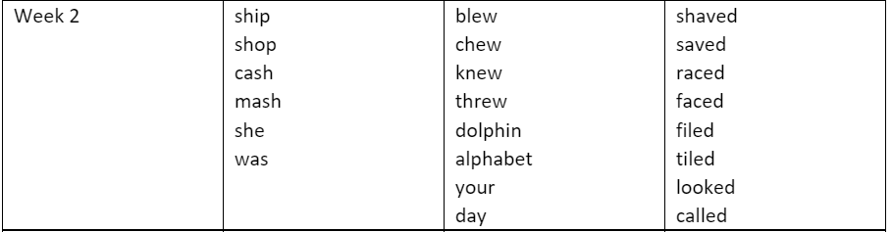
Group 1 Group 2 Group 3

