Homework – Friday 20th January

In Parrots, we really encourage practical learning and engaging activities; not everything has to be wrote down on pen and paper. You could chalk your spellings, create word searches or even draw pictures linked to your spellings. Maths might be on Education City or it might be practical.
Any questions please do email and let us know if you have any problems.
This week please email homework to Mrs Davis

PLEASE NOTE: If you have any messages for the class teacher, either send an email or catch them on the door in the morning or after school. We don’t always check reading journals on a daily basis.

Maths- Education City – Please find log in details on the home learning page. Access the level appropriate for you.
Writing- Can you write a list of all the words that end in the suffix -ful? Maybe you could write a sentence about the seaside using a -ful word.
Topic – Can you find out what a herbivore, carnivore and omnivore is?

TTRS/Numbots (Please access these as and when you can)
Year 2: please practice your 2’s, 5’s, 10’s, 3’s times tables on TTRS
Year 1: Numbots – please see username and password information in reading journals and do this every night (it will help with place value/number work.) Work your way through the levels and keep at it.
IDL: Logins will be in reading journals this week so that you can access 3 times a week at home.

Spellings

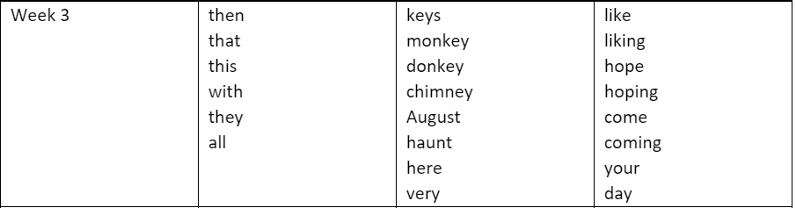
Group 1 Group 2 Group 3

