Homework – Friday 27th January

In Parrots, we really encourage practical learning and engaging activities; not everything has to be wrote down on pen and paper. You could chalk your spellings, create word searches or even draw pictures linked to your spellings. Maths might be on Education City or it might be practical.
Any questions please do email and let us know if you have any problems.
This week please email homework to Miss Lee

PLEASE NOTE: If you have any messages for the class teacher, either send an email or catch them on the door in the morning or after school. We don’t always check reading journals on a daily basis.

Maths- Education City – Please find log in details on the home learning page. Access the level appropriate for you.
English- Please have a go at the grammar activity on Education City. After you have had a go why not try writing some sentences and making sure you have added capital letters and full stops. If it is a question what do we need at the end?
Topic – In Geography we have been looking at human and physical features. Remind your grown up what this means and when you are out and about at the weekend, try and point out some of these features in your local area.

TTRS/Numbots (Please access these as and when you can)
Year 2: please practice your 2’s, 5’s, 10’s, 3’s times tables on TTRS
Year 1: Numbots – please see username and password information in reading journals and do this every night (it will help with place value/number work.) Work your way through the levels and keep at it.
IDL: Logins will be in reading journals this week so that you can access 3 times a week at home.

Spellings

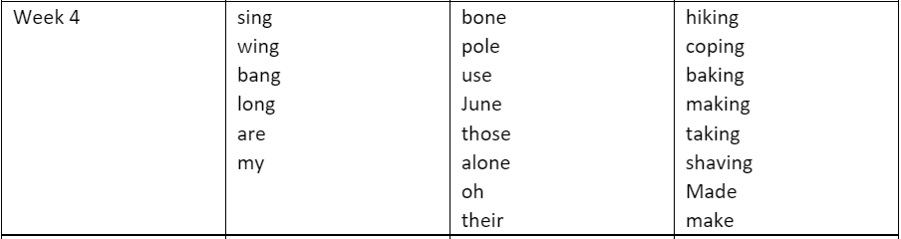
Group 1 Group 2 Group 3

