Homework – Friday 3rd February

In Parrots, we really encourage practical learning and engaging activities; you don’t have to write all your homework down on pen and paper. You could chalk your spellings, create word searches or even draw pictures linked to your spellings.
Any questions please do email and let us know if you have any problems.
This week please email homework to Mrs Davis

PLEASE NOTE: If you have any messages for the class teacher, either send an email or catch them on the door in the morning or after school. We don’t always check reading journals on a daily basis.

Maths- Education City – Please find log in details on the home learning page. Access the level appropriate for you – you don’t have to do them all
Reading- Continue to read your reading book daily and discuss key things such as characters, tricky spellings, the plot, the setting etc.
Topic – In Music, we have been listening to a rock song called ‘I wanna play in a band’. Spend some time this weekend listening to other songs you might like and discuss with your grown up why you like them and how they makes you feel. Can you find the pulse? Can you hear any instruments?

TTRS/Numbots (Please access these as and when you can)
Year 2: please practice your 2’s, 5’s, 10’s, 3’s times tables on TTRS
Year 1: Numbots – please see username and password information in reading journals and do this every night (it will help with place value/number work.) Work your way through the levels and keep at it.
IDL: Logins will be in reading journals this week so that you can access 3 times a week at home.

Spellings

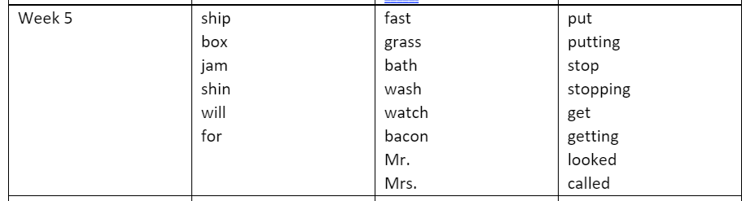
Group 1 Group 2 Group 3

